Probability

Decision Theory 🡪 Probability + Utility  
Utility 🡪 Maximizing expected performance.  
  
Prior Probability 🡪 Probability of events that are not dependent on another event.  
example 🡪 P(A), P(B), P(C) etc.

Mutually Exclusive Events and Non-Mutually Exclusive Events  
Event that cannot happen at the same time are called mutually exclusive events.  
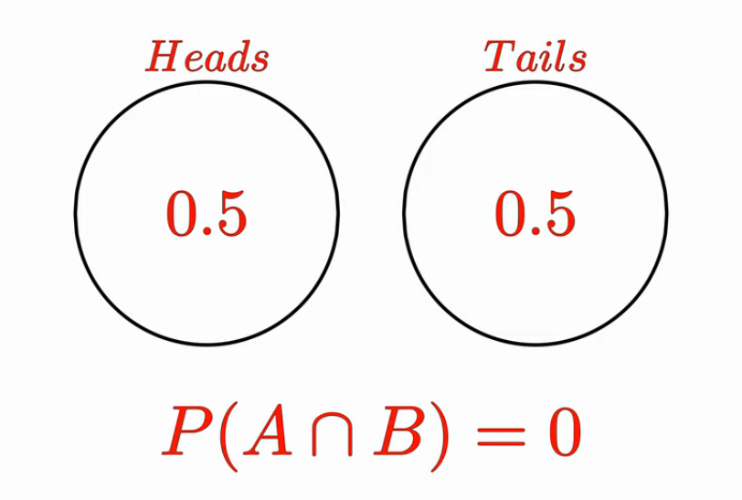

Both head and tail cannot come together at the same time.  
Mutually exclusive events cannot be independent events.  
Independent events cannot be mutually exclusive events.  
  
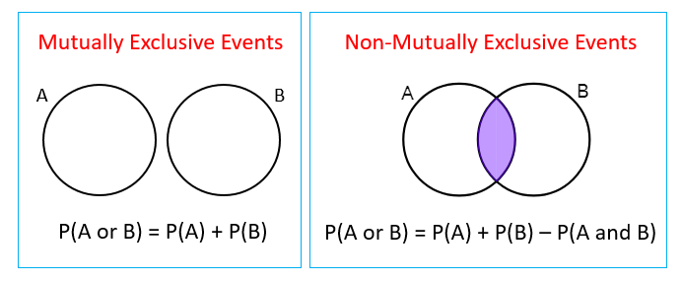  
  
Independent Events: When the occurrence of one event does not affect the occurrence of the other P (A int B) = P (A) * P (B) Dependent Events: When the occurrence of one event does affect the occurrence of the other P (A int B) = P (A) * P (B), where P (B) is adjusted based on the results of event A.  
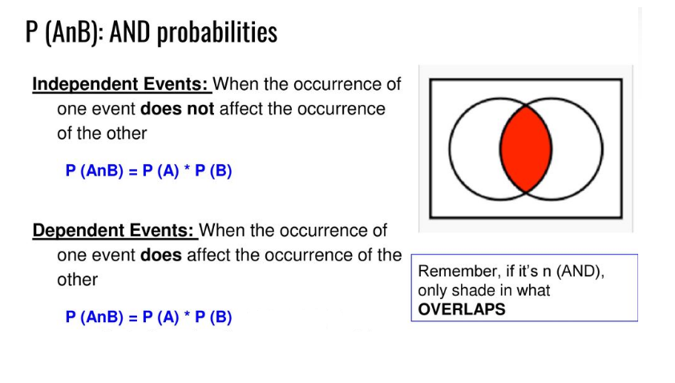  
  
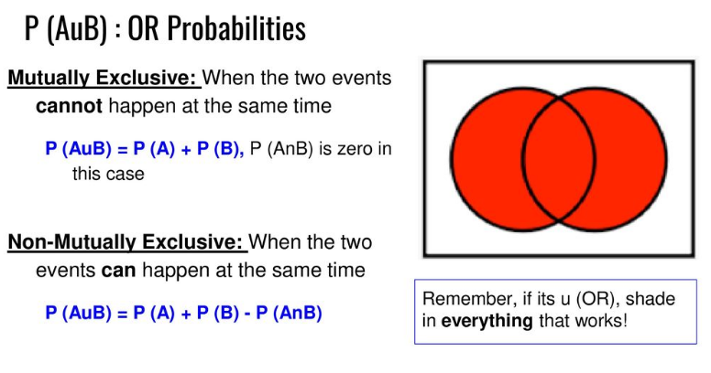  
Mutually Exclusive: When the two events cannot happen at the same time P (AuB) = P (A) + P (B), P (A int B) is zero in this case  
  
Non-Mutually Exclusive: When the two events can happen at the same time P (AuB) = P (A) + P (B) - P (A int B)   
Example for mutually exclusive 🡪 single coin toss  
Example for non-mutually exclusive 🡪 multiple coin toss  
  
  
  
Conditional Probability 🡪 Probability of event that is dependent on occurrence of other events.  
example 🡪 Probability of event 🡪 covid patients is dependent on event 🡪 symptoms  
Covid will happen only when a patient has its symptoms therefore, covid event is dependent on symptoms event and the symptom event should be “Given” or there should be an “Evidence(Information about event on which first event depends)” to calculate the probability of “Covid”.  
Mathematically 🡪 Probability(Covid | Symptoms)   
P( “Any Effect” Given “Any Cause”)  
“|” means 🡪 “Given that” or “Evidence” or “Probability with current context X” or “with respect to already happened event P(A) or P(A’) in past”

Probability A Given B 🡪 P(A|B) = Intersection of A, B / P(B) 🡨 (Only if event A is dependent of event B)  
  
Probability A Given B 🡪 P(A|B) = P(A)*P(B) / P(B) 🡨 (Only if event A is independent of event B)  
because, independent events 🡪 A Int B = P(A)*P(B)  
so after simplification,   
Probability A Given B 🡪 P(A|B) = P(A) 🡨 (Only if event A is independent of event B)

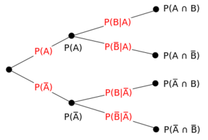  
  
  
  
  
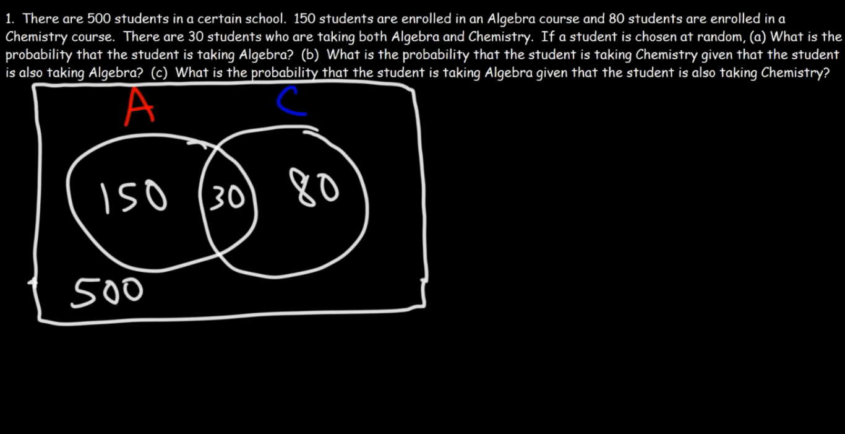  
Part (A)  
P(A) = Students in Algebra / Total  
P(A) = 150 / 500  
P(A) = 0.3  
  
  
Part (B, C)  
P(C|A) 🡨 Probability of “Chemistry” students when students are in Algebra?  
P(C|A) = Intersection / (Total student in Algebra)   
P(C|A) = 30/150   
P(C|A) = 1/5  
P(C|A) = 0.2  
  
P(A|C) 🡨 Probability of “Algebra” students when students are in Chemistry?  
P(A|C) = Intersection / (Total student in Chemistry)   
P(A|C) = 30/80  
P(A|C) = 3/8  
P(A|C) = 0.375  
  
  
  
  
  
 Bayes Rule  
  
  
  
P(A|B) = P(A int B) / P(B) P(B|A) = P(B int A) / P(A)   
P(A|B) * P(B) = P(A int B) P(B|A) * P(A) = P(A int B)   
P(A int B) = P(A|B) * P(B) P(B int A) = P(B|A) * P(A)  
  
Since, P(A int B) = P(B int A)  
So,  
 P(A|B) * P(B) = P(B|A) * P(A)  
 Therefore,  
 P(A|B) = P(B|A) * P(A) / P(B) 🡨 Bayes Rule Notation  
 P(B|A) = P(A|B) * P(B) / P(A) 🡨 Bayes Rule Notation

Given  
  
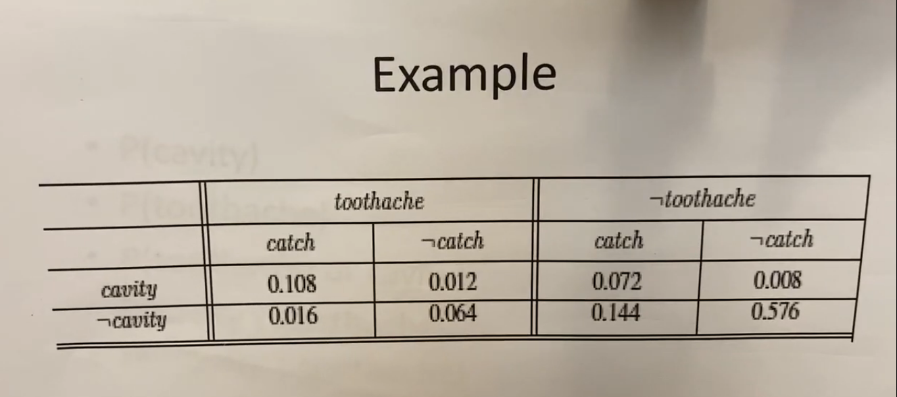  
  
To Find  
  
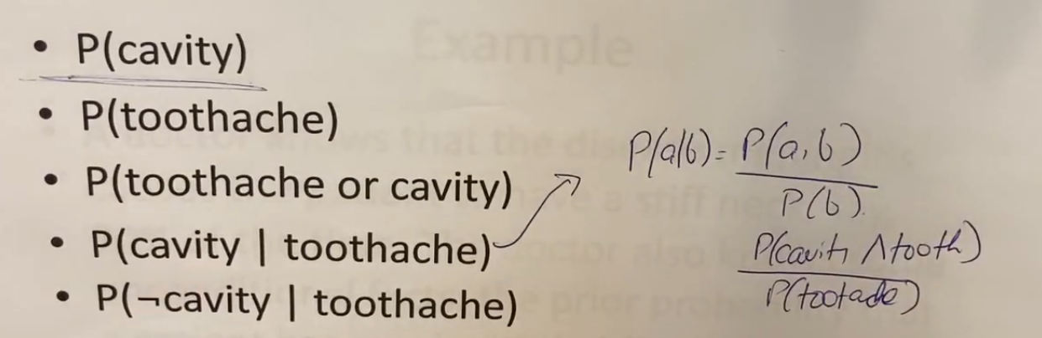  
  
First find all the possible cases (joint probability distribution) for all the required probability calculations,  
“**2** cases for toothache and not toothache”  
“**2** cases for cavity and not cavity”  
“**2** cases for catch and not catch”  
Therefore total joint probability 🡪 2*2*2 = 8  
  
For each probability calculation let say if we are calculating P(cavity) then we must consider all the **possible cases**, find probability of each case and then add them to find the final probability. For example, the P(cavity) = 0.108+0.012+0.072+0.008 (because it was not given to only consider a specific case that is why we will consider all the possible cases, calculate their probabilities and add then for final probability calculation).  
  
For P(Toothache) 🡪 sum all the values of toothache columns including both cavity and not cavity.   
For P(Toothache) 🡪 0.108 + 0.012 + 0.016 + 0.064  
  
For P(Cavity Given Toothache) 🡪 Cavity int Toothache / P(Toothache)   
Numerator 🡪 intersection of first 2 columns of Toothache with entire row of Cavity which is,  
 🡪 0.108 + 0.012  
therefore,  
For P(Cavity Given Toothache) 🡪 [ 0.108 + 0.012 / 0.108 + 0.012 + 0.016 + 0.064 ]  
  
For P(not Cavity Given Toothache) we don’t have to calculate it again because,  
P(A|B) == 1 – P(A’|B)   
(Only if given that information or evidence is same and numerator compliment has to be calculated)  
because the given that information is same, the denominator of both P(Cavity Given Toothache) and P(not Cavity Given Toothache) are equal that is P(Toothache) which is called “Normalization factor or constant”.  
  
But P(A|B) != 1-P(A|B’)  
so, P(not Cavity Given Toothache) 🡪 1 - P(Cavity Given Toothache)

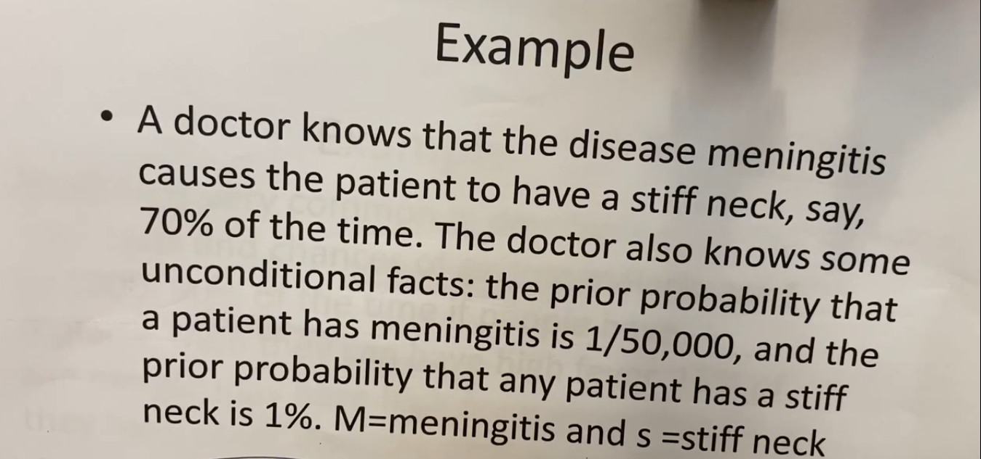  
  
P(S|M), P(M), P(S)  
  
  
  
  
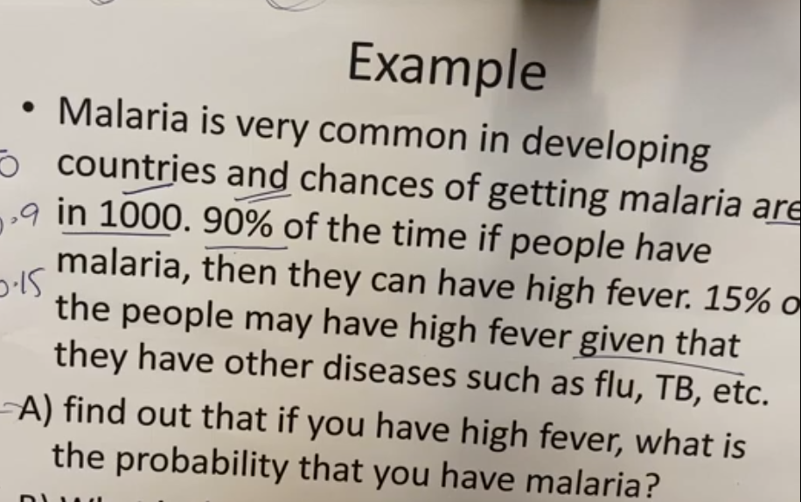  
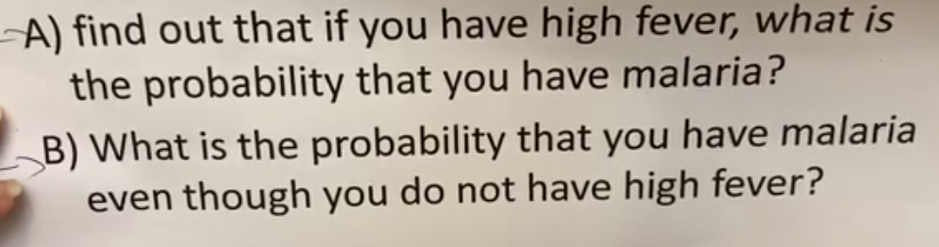  
  
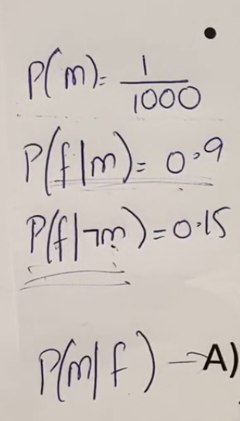  
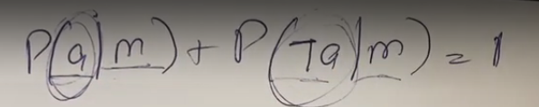  
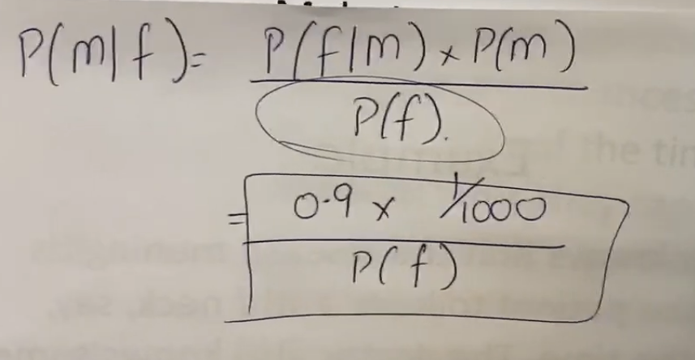  
  
Here P(F) is not given so we will calculate that first consider all the possible cases of ‘F’ and then will add all those cases to get final probability.  
Therefore,  
  
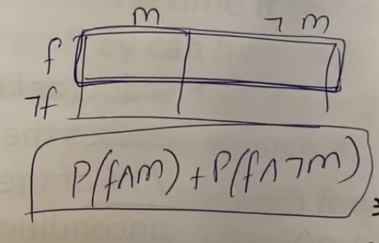  
  
P(F) = P(F int M) + P(F int not M),  
F means entire first row, M means first column so “AND”/intersection of the first column (M) and first row F can give P(F|M). Same for ~M.  
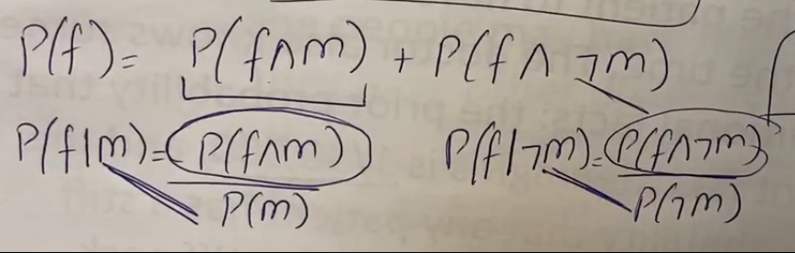  
  
Now everything is given and therefore P(F) can be calculated as,   
P(F) = P(F|M) * P(M) + P(F| not M) * P(not M)  
  
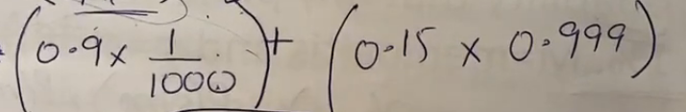  
  
Now for **P(M | not F)**,  
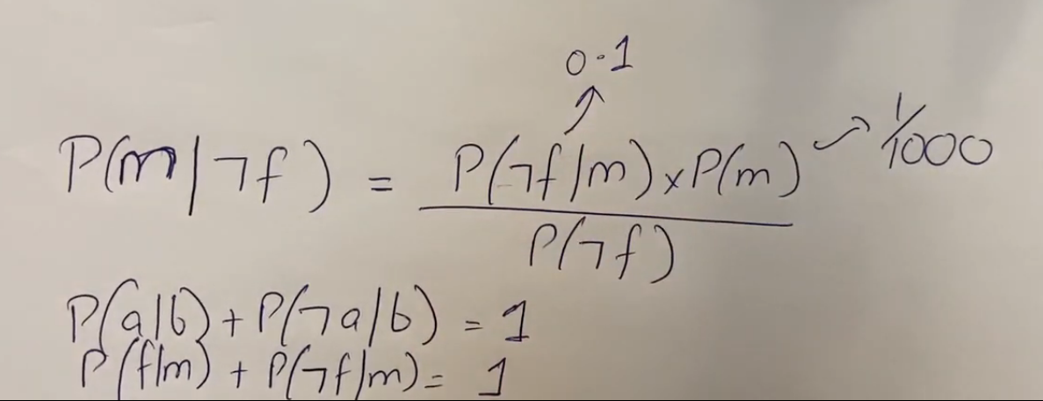  
  
for P(not F) 🡪 1- P(F) 🡨 P(F) was already calculated in previous part.  
  
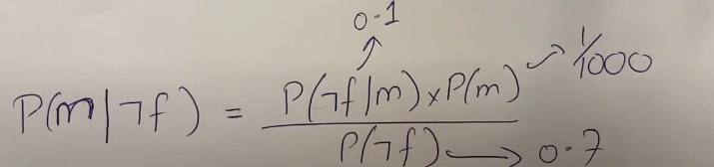  
  
  
  
  
  
  
  
  
  
  
  
  
  
 Naïve Bayes Classification  
  
Naïve Bayes classification is only applicable when features are independent of each other. If we apply naïve bayes on dataset having dependent features, then we will be getting huge loss in accuracy.  
  
There are two types of Naïve Bayes classification,  
1. NB for Discrete variables (variables with fixed range values).  
2. NB for Continuous variables (variables with continuous values like 5.86562795…).  
  
 Naïve Bayes for Discrete variables   
 (Variable with fixed limited range values)  
  
In this type of NB, we are given with training data set having both features as well as output labels i.e., Supervised Learning)  
  
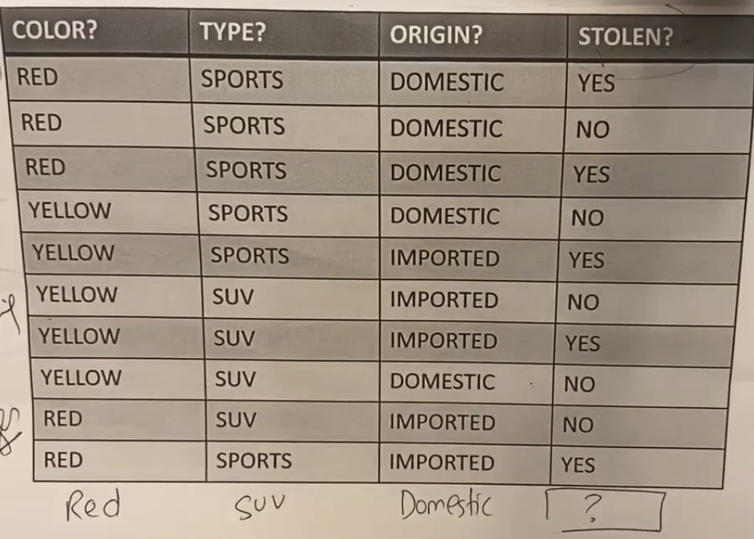  
  
For this type of classification we will calculate probability of all the “Available Output Labels” given that all the features and the label with highest probability will be assigned to this new data (Red, SUV, Domestic).  
  
Total Output Labels 🡪 2 (YES or NO)  
Therefore, Probability(Output = n possible or available output labels | all given features) will be calculated.  
🡪 P(Stolen = YES | R,S,D) 🡨 if this is > P(Stolen = NO | R,S,D) then Ans will be “YES”  
🡪 P(Stolen = NO | R,S,D) 🡨 if this is > P(Stolen = YES | R,S,D) then Ans will be “NO”  
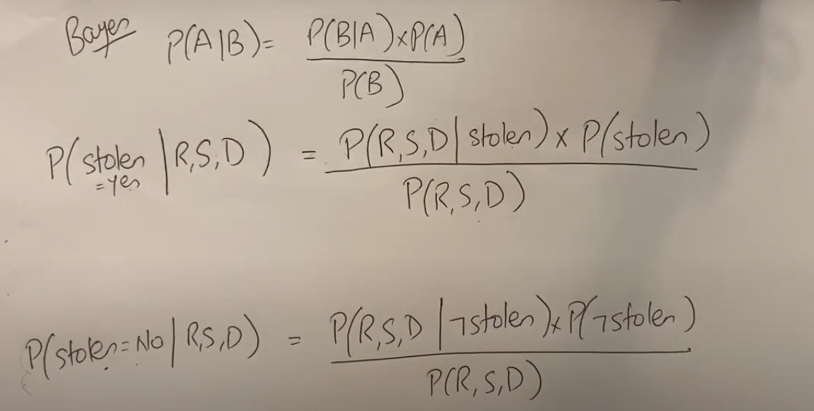  
  
P(Red|Stolen) = Total Reds when Stolen was “YES” / Total YES counts in output features  
P(SUV|Stolen) = Total Reds when Stolen was “YES” / Total YES counts in output features  
P(R|Stolen) = Total Reds when Stolen was “YES” / Total YES counts in output features  
Here Stolen means 🡪 when stolen was “YES”  
  
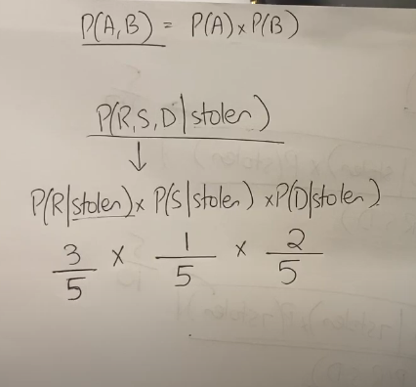

P (Red | not Stolen) = Total Reds when Stolen was “NO” / Total NO counts in output features  
P (SUV | not Stolen) = Total Reds when Stolen was “NO” / Total NO counts in output features  
P (R | not Stolen) = Total Reds when Stolen was “NO” / Total NO counts in output features  
Here not Stolen means 🡪 when stolen was “NO”  
  
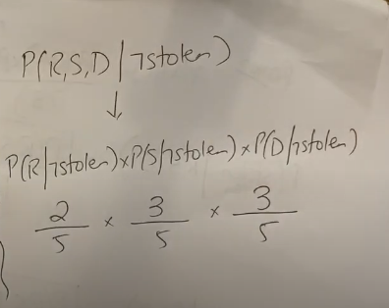

Now, since the denominator is same for both the cases which is P (R, S, D) which is “Normalization factor or constant” which can be calculated as,  
Normalization factor P (R, S, D) = Sum of numerators of all the output label cases YES, NO etc.  
Therefore,   
P (R, S, D) = [   
 [P (Red | Stolen) * P (SUV | Stolen) * P (R | Stolen)] * P(Stolen)   
 +   
 [P (Red | not Stolen) * P (SUV | not Stolen) * P (R | not Stolen)] * P(not Stolen) ]   
 ]  
  
We can ignore this denominator because all the cases will be divided with same normalization factor or constant so we can directly check the numerator only and the case having largest numerator value will be having highest probability value too because dividend is same for all.  
  
Therefore,  
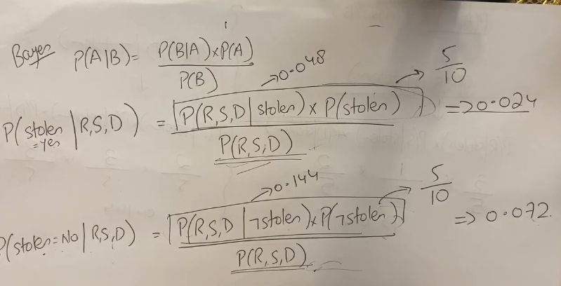  
  
since, 0.072 > 0.024  
Therefore, “NO” will be assigned to this new data having feature values (Red, SUV, and Domestic).

Example # 2  
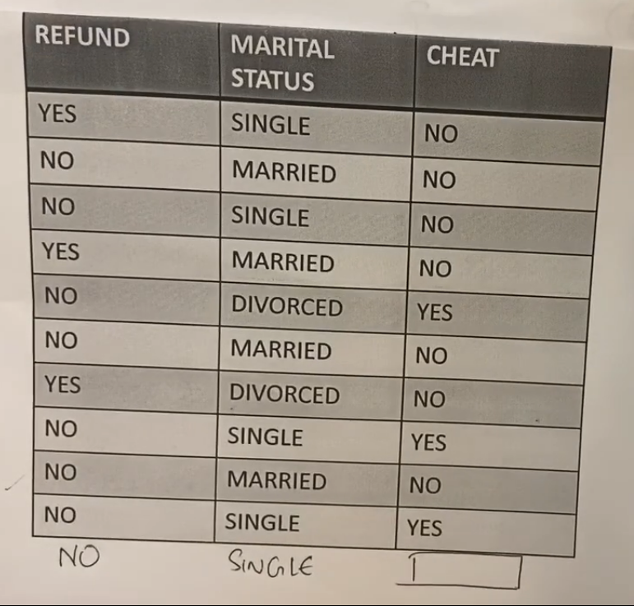  
  
Answer  
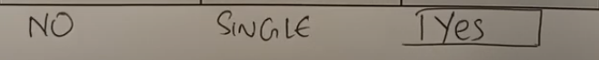

Gaussian Naïve Bayes for Continuous variables   
 (Variable with fixed limited range values)  
  
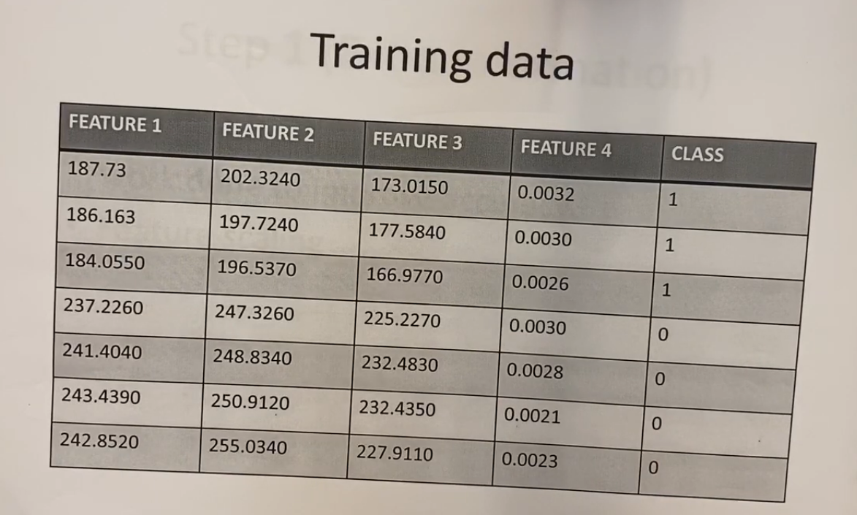  
  
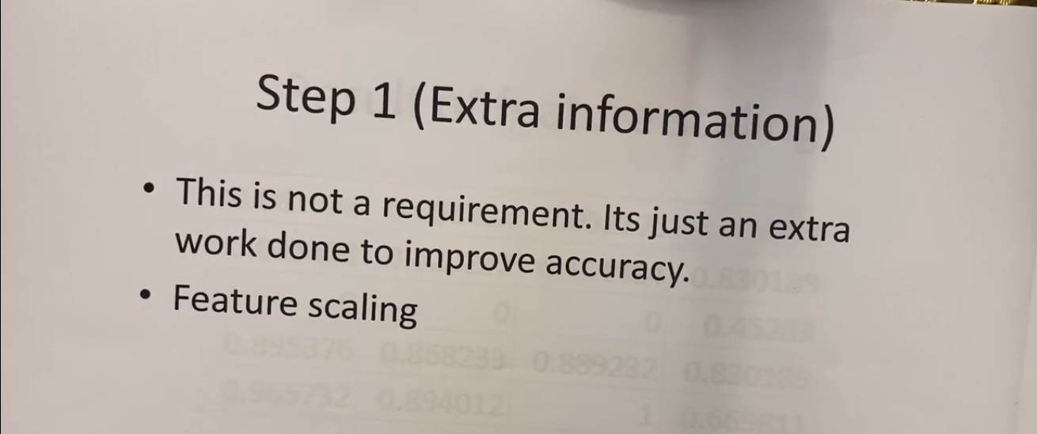  
  
  
  
  
  
  
Feature Scaling Formula  
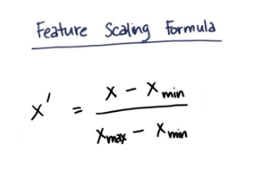  
- [Current value of column – Minimum value of column] / [Maximum value of column - Minimum value of column]  
There are other formulas also available we can use them also but for now we will use this formula.  
  
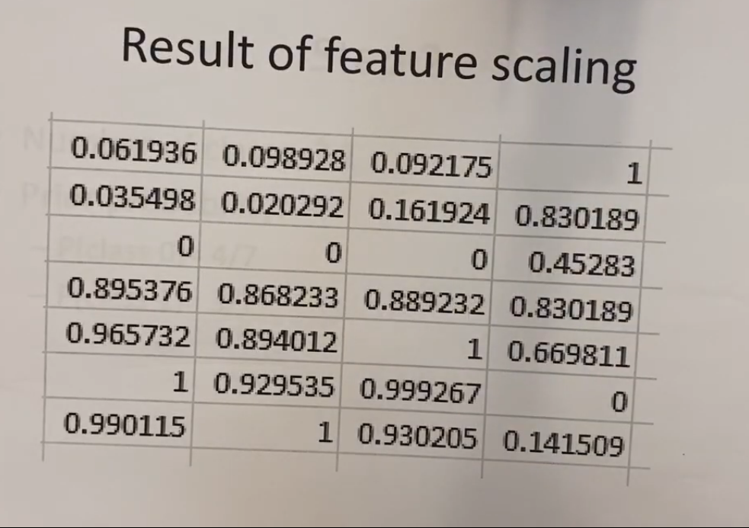  
  
Using this formula we can scale the features in range of 0 🡪 1 normal distribution (we use gaussian distribution most of the times in this continuous variant of naïve bayes that is why we call it gaussian naïve bayes but we can use other distributions also) and now the entire dataset will be having values in range from 0 🡪 1 (making a gaussian distribution). This will help in,  
- Reducing complex calculations  
- Helps in improving accuracy up to double because values are not diverged anymore (values come closer and all the outliers comes nearer se mean is not that much affected due to the outliers because in normal dataset the outlier may affect the mean which can reduce the accuracy let suppose if all the values were in range of 1🡪 100 but 1 value is of 1000 so this will drastically affect the mean so by doing feature scaling this problem can be solved and the affect of outliers can be reduced because it brings entire dataset in a gaussian or normal distribution having 0🡪1 range values. Therefore, outlier’s noise can be reduced)  
  
Another feature scaling formulas,  
  
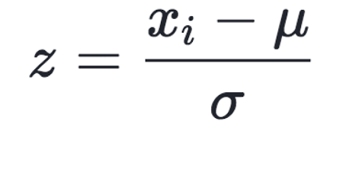  
After feature scaling, calculate prior probabilities (probabilities without any given that conditions) of all the classes or output labels.  
  
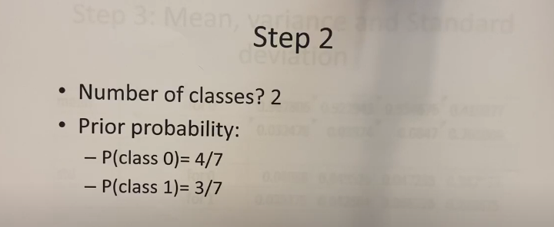  
  
  
  
  
  
  
  
  
  
  
  
  
  
  
  
  
 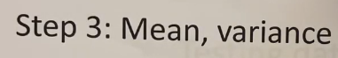  
  
Calculate mean of each feature column for all the available classes in output,  
When calculating mean, variance for class ‘0’ only consider rows that has output ‘0’.  
When calculating mean, variance for class ‘1’ only consider rows that has output ‘1’.  
  
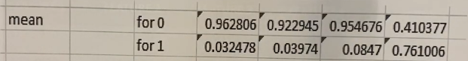  
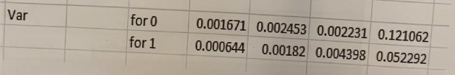  
  
Mean = Sum of point having row output as current class / Total Points  
Variance = Summation of (Each point or value having row output as current class – Mean)^2 / Total Points  
  
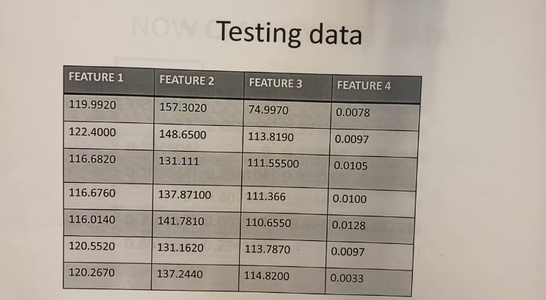  
  
Now we will have to assign labels to this testing data provided by the client.  
  
  
  
  
  
Also apply feature scaling to the testing dataset,  
  
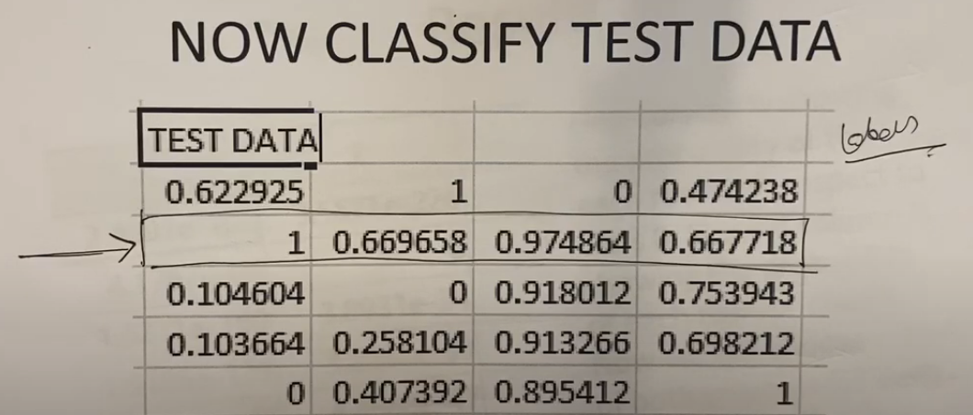  
  
Testing on following row,  
  
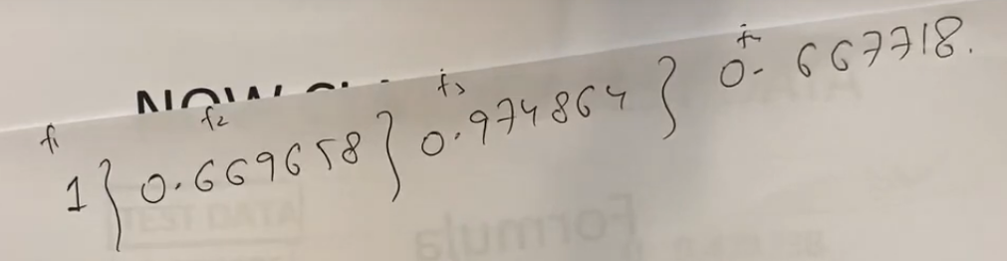  
  
The formula for probabilities for all the output labels is similar as we did for discrete dataset.  
  
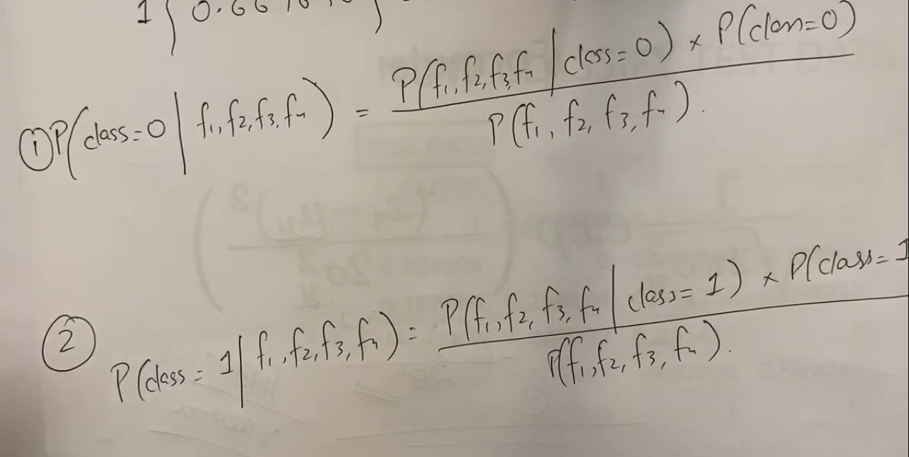  
  
but in discrete values case we were calculating probabilities of features P(“any feature” given “any class”) from the table directly by favorable/total outcomes, but here the probability for features P(“any feature” given “any class”) is calculated by the formula given below because we now have continuous values,  
  
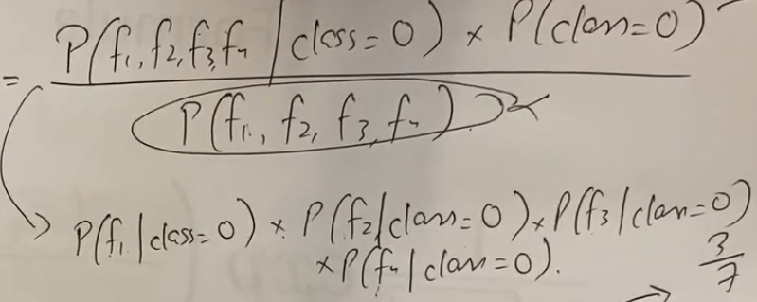  
  
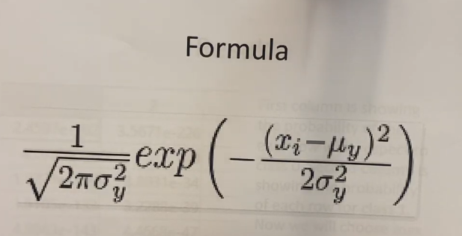  
  
where   
xi 🡪 Current testing feature value in testing row  
Mew 🡪 Mean  
Sigma 🡪 Variance  
Calculating probabilities of all the testing features,  
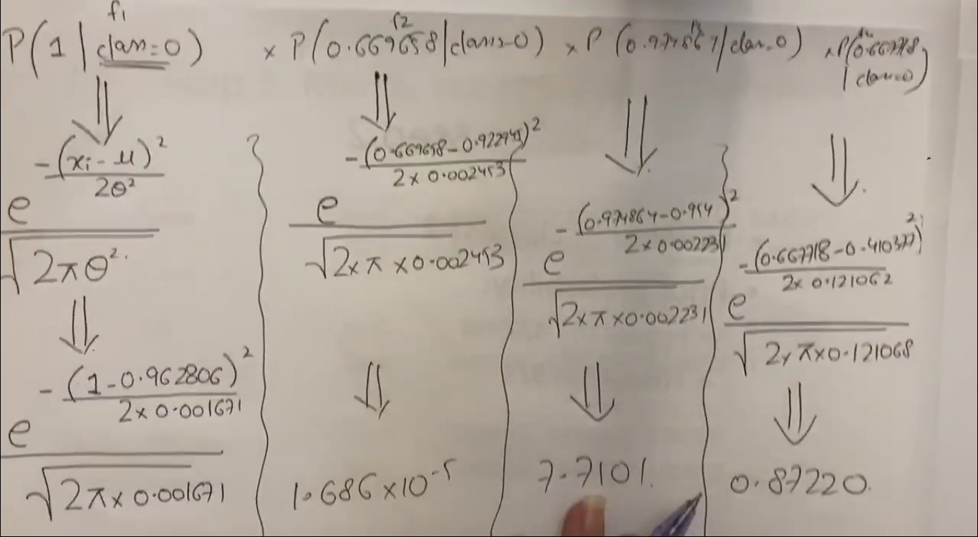  
  
If any of the probability value is ‘0’ then we will not calculate probability of remaining features because it will be multiplied with 0 and it will then make entire feature probability 🡪 0  
  
  
  
  
  
  
  
  
  
  
  
  
  
  
  
  
  
  
  
  
  
  
  
  
  
  
  
 Bayesian Network  
  
In Bayesian network, instead of working on independent features, we work on dependent features because we use Naïve Bayes and Gaussian Naïve Bayes only when the features are independent of each other or there is no co-relation between them.  
  
  
All the child nodes 🡪 dependent nodes of their parents.  
  
**Dependent Probabilities Calculations,  
If A is dependent on B and B is dependent on C then probability of A will be,  
🡪 (Probability of A given its parent) * Parent’s probability ….  
🡪 P(A | All the parents of A) * P(Parent of A| Grandparent of A)… Till we get a variable having a prior probability  
🡪 P(A|B) * P(B|C) * P(C)   
Here C was independent of any other node therefore, P(C) is independent probability so we stopped here otherwise if it will be having any parent, then we would have continued this process until we independent variable probability.  
  
Note: If any independent probability or dependent probability is already present due to the previous terms, then we don’t include them again because they will automatically be multiplied with that value from previous terms.**  
  
Here, when we are calculating P(Weather, Toothache, Catch, Cavity),  
Note that, the probability P(Toothache | Cavity) should be multiplied with Toothache’s parent probability that is,  
“P(Cavity)”, but we did not multiply it with P(Cavity) because P(Cavity) already exist in previous terms. We only multiply when the parent terms do not exist before.  
  
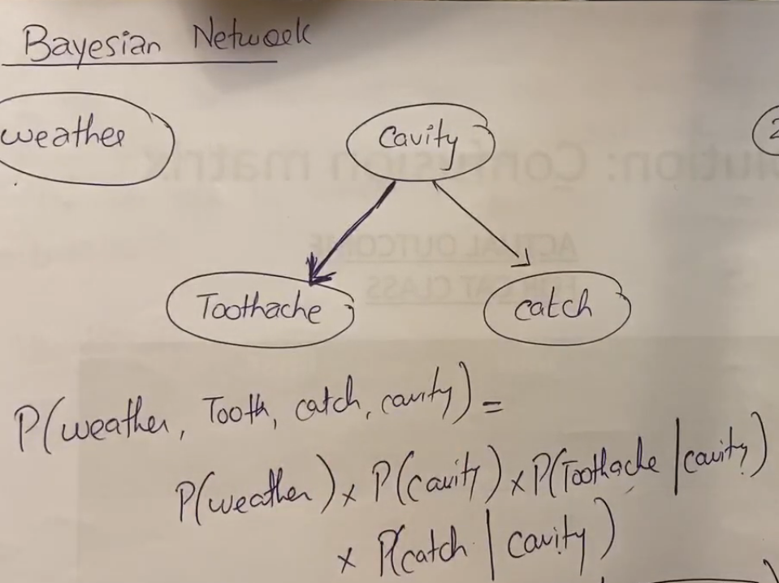   
  
Here weather 🡪 solo node which neither have any child nor any parent.  
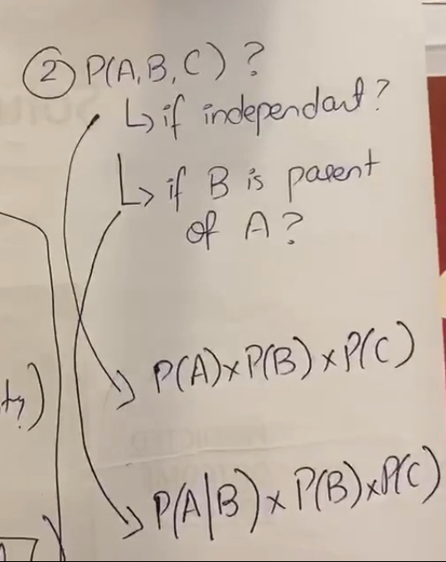  
  
  
  
  
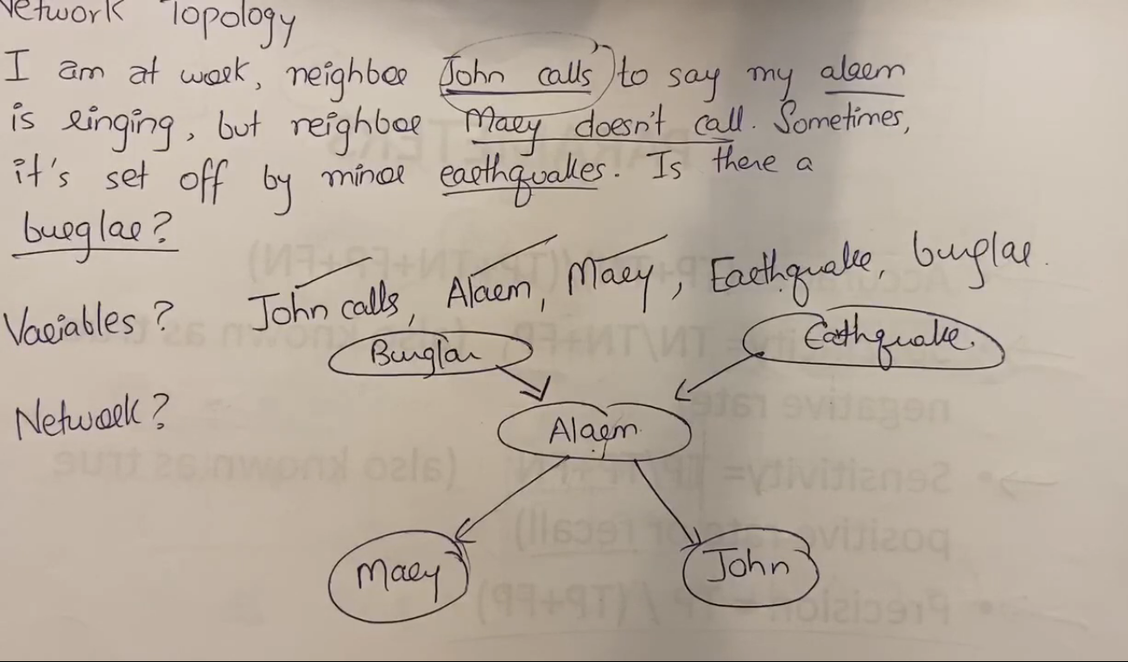  
  
- First write down all the variables from the question  
- See which variable depends on what and construct the graph.  
  
Probability of (John AND Mary AND Burglar AND Alarm AND Earthquake)  
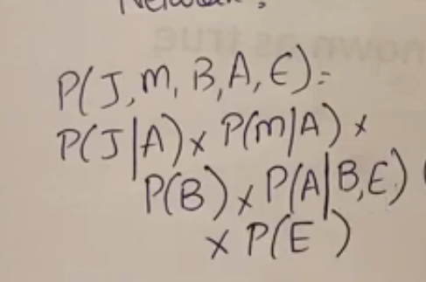  
  
Example,  
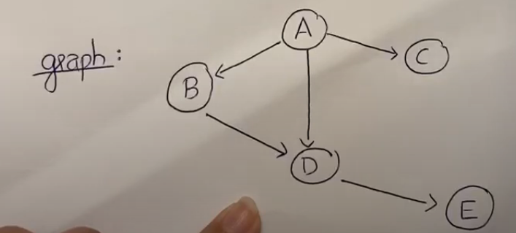  
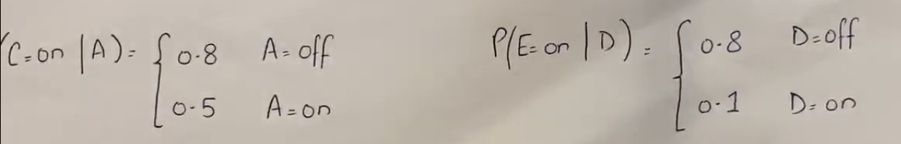  
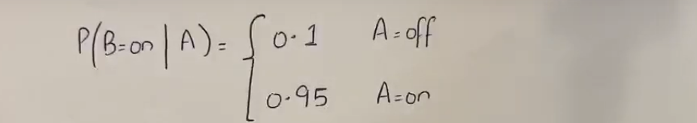  
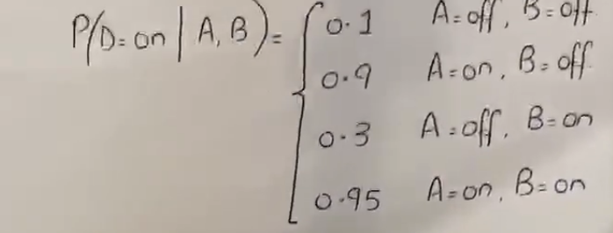  
  
  
  
  
  
Find Following,  
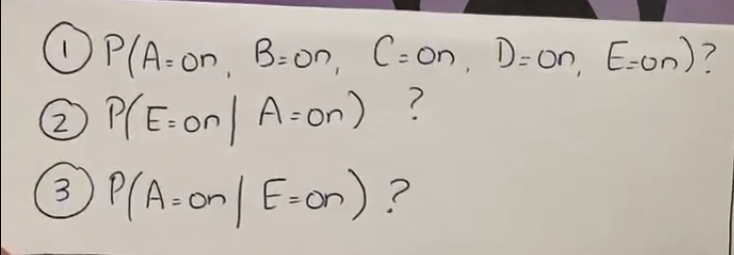  
  
Solution # 1  
  
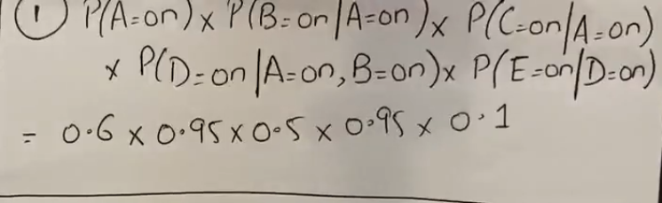  
  
In solution # 1 we are given the information of all the variable’s state. So, we don’t have to consider probabilities having other states during the calculation of the probability of A. The probability is calculated only of the first variable written (like A=ON here) and all other variables (B=ON,C=ON,D=ON,E=ON) are “Only extra information about states of parents required to calculate the probability of first variable”.  
  
  
  
  
  
  
  
  
  
  
  
  
  
  
  
  
Solution # 2  
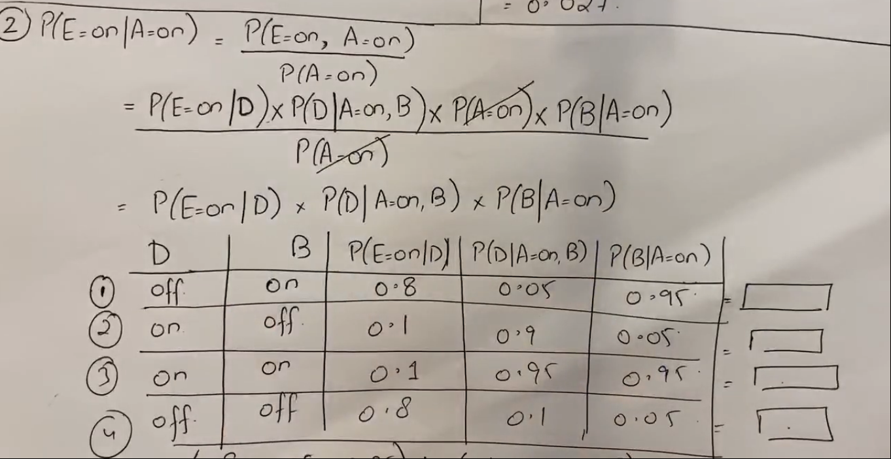  
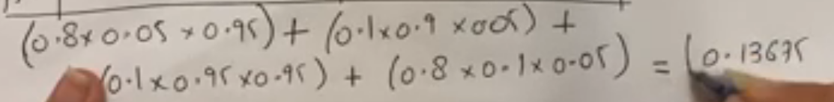  
Note: In solution # 2, we were given E=ON and A=ON which means,  
Calculate probability of E=ON when Given A=ON, so we have to find the probability of “E” only, the information that comes after as Given information like here “A=ON”, it does not mean that we will have to calculate the probability of A also. We only have to Find probability of E=ON only. Here A=ON is an additional information so that when we will be calculating probability of E and its parents, we will only consider A=ON case and not the A=OFF case because A=ON was GIVEN but those parent variables whose information is not provided, we will calculate their probabilities with all the possible state cases.   
  
- Compute and open the required probability formula using the Bayesian rule,  
 **🡪 (Probability of A given its parent) * Parent’s probability …. Till we get a variable having an independent probability**  
  
- Now we write only the variables whose information was not given (variables 🡪 D and B information was not given) in separate columns. Total such variables 🡪 2 (incomplete information variables)  
Therefore 2^n possible cases here n 🡪 2 so 2^2 = 4 possible cases.  
ON ON  
OFF OFF  
ON OFF  
OFF ON  
  
Since E=ON, A=ON was already given so we will keep them ON for all the cases.  
  
Also, those probabilities that does not include some incomplete information variables like P(E=ON|D) does not have ‘B’ (incomplete information variable) so we will not consider B=ON, B=OFF etc. we will only consider case values of D not of B for this case because B does not exist in this probability calculation.  
  
  
  
  
  
  
  
Solution # 3  
  
“Solve before paper”  
  
  
 Clustering  
  
It is a process in which we don’t have output labels anymore like we had in Naïve Bayes and Gaussian Naïve Bayes. We only have data, we will be learning some patterns from that data and then dividing that data into some clusters. This is unsupervised learning approach because we do not have labelled data anymore (data having output feature with some classes or labels) instead, we are making our own output labels (clusters).  
  
Types of Clustering  
1. Partitioning (e.g., K-Means).  
2. Hierarchical.  
3. Density Based.  
  
Applications  
- Document’s clustering.  
- Image pattern clustering (Grouping all the possible images of similar patterns into one identity or cluster, let say number ‘8’ can be written in multiple ways so there can be thousands of images of number ‘8’ that should be represented as ‘8’)  
- Outlier’s detection (To cluster outlier values in a separate cluster because it will not lie under the given value range so a separate cluster will be created if any outlier comes)  
- Web apps, Customer’s data clustering  
etc.  
  
Types of Algorithms  
- K-Means 🡨 convergence point comes too fast, always make spherical shape clusters.  
- K-Mode 🡨 convergence point comes too late, can work on non-numeric dataset as well, picks mode or most repetitive values.  
- K-Medoids 🡨 convergence point comes too late, picks median after sorting.  
  
  
  
  
  
  
  
  
  
  
  
  
  
  
  
  
  
  
  
  
 K-Means Algorithm  
  
- It works only on numeric dataset.  
- Sensitive to outliers (let say if 1 point in the cluster is too much far so when calculating the mean for the next iteration centroid, it may result in generating inefficient centroid points.  
  
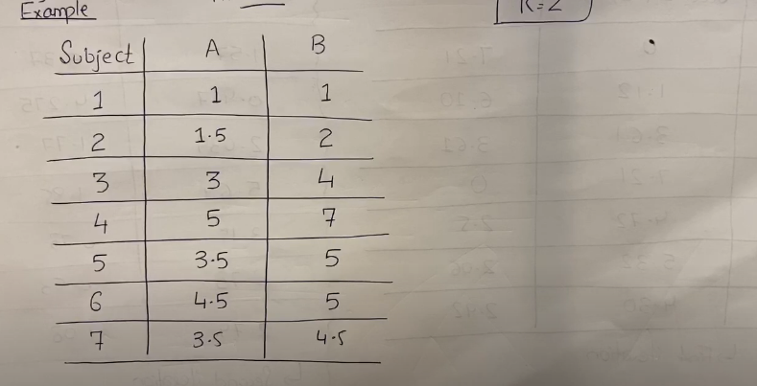  
  
Step # 1 (Select a K value which means how many clusters we want to make)  
This should not be picked randomly, because if let say there are 50 documents and if we set K = 50 then this is not good approach to make separate cluster for each document. This is garbage approach. This is why we want good value of K. We can get an appropriate K value by drawing a graph whose Y-Axis is the sum of square error of the data points from the centroids, and the X-Axis will be having K values in increasing order. The point at which we get a broken or flat curve, is the point where the best K value lies. This point in graph is called “kick point”  
  
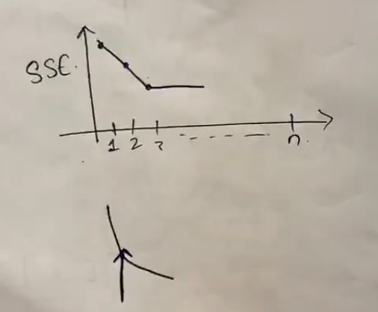  
  
  
  
  
Step # 2 (Randomly pick initial K centroid seeds if not given or mentioned)  
  
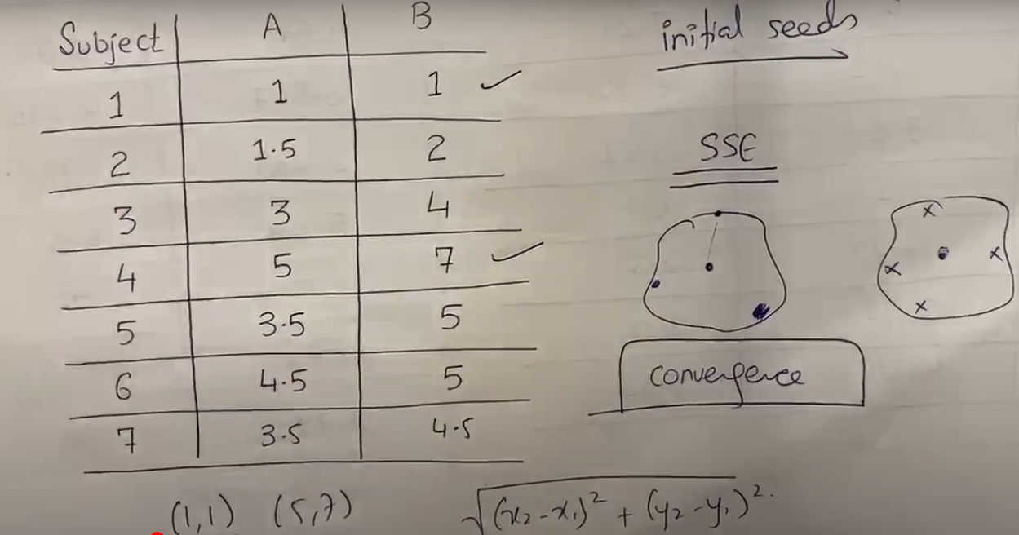  
  
In this case, the cluster value or the K value was 2 that is why we chose two initial centroid seeds. These initial seeds (1,1) and (5,7) are the center points of each of the clusters (centroids).

Step # 3 (Calculate distance of each point (x, y) with each centroid point (1,1) , (5,7) )  
  
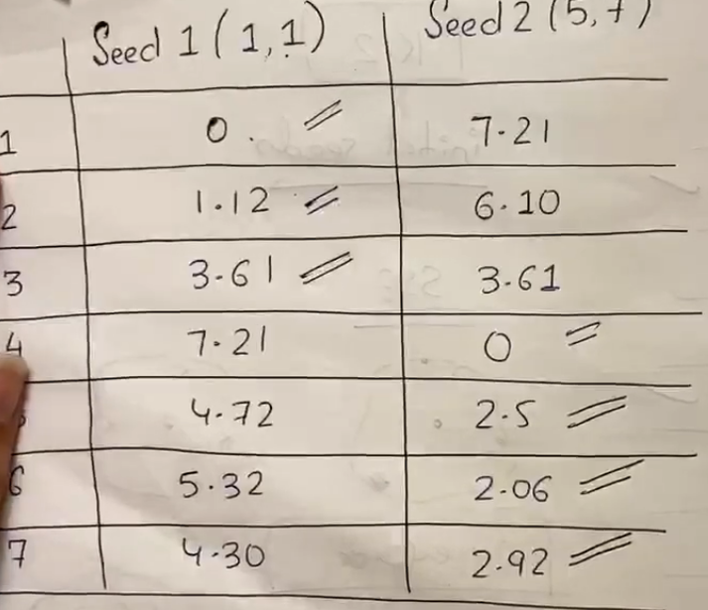  
  
Assign points to the formed clusters by checking which centroid has minimal distance from the point either centroid/seed 1 or centroid/seed 2. The cluster with the minimal distance from points its centroid-point will get that point in that cluster.  
  
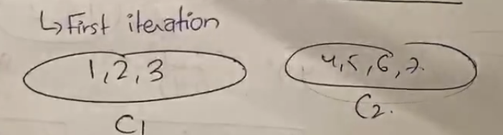  
  
  
c1 🡪 cluster # 1 c2 🡪 cluster # 2  
  
Step # 4 (sum all the X and sum all the Y co-ordinates and divide by total to calculate centroid for next iteration)  
The first centroid point will be calculated from the points assigned to cluster # 1 in first iteration. Similarly, the second centroid point will be calculated from the points assigned to cluster # 2 in iteration # 1. If we had K clusters then K centroids would be calculated.  
  
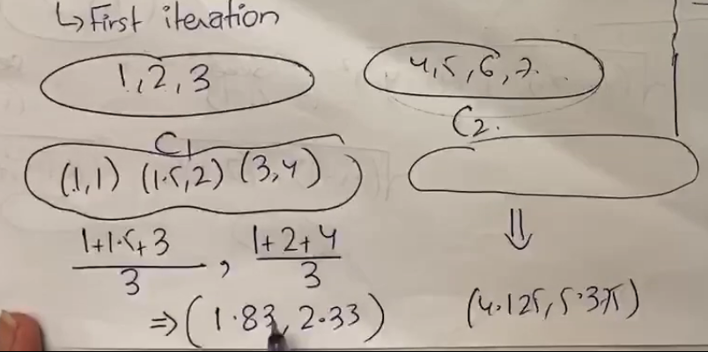  
  
**Repeat these steps for other iterations as well and stop only when the current iteration forms the same clusters as last iteration did. (convergence)**  
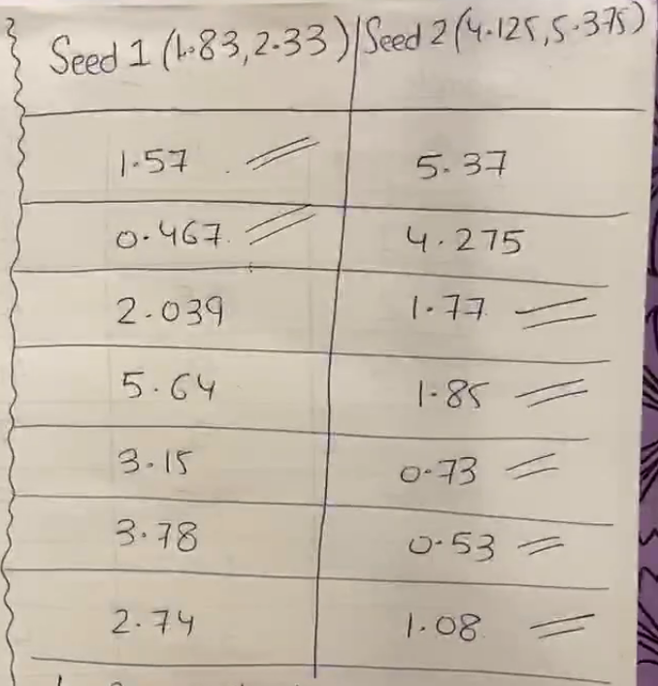  
  
Silhouette Coefficient  
It is a technique to validate whether our clusters are good enough or not. Its value is between -1 to 1. If we get silhouette coefficient value > 0.7 or nearer to 1 then our clusters are extremely good otherwise if they are nearer to 0 and -1 then our clusters are not good. **Formula 🡪 B-A / Max (B, A)  
  
Here,  
A 🡪 distance from the same cluster points (this is also called cohesion)  
B 🡪 distance with other clusters (this is also called separation)**

Decision Tree

* Works on discrete values only.
* Follows Inductive inference approach.
* Algorithms like ID3 are used to implement decision tree.
* Provides a tree-based structure for decision making.
* Can be used with dataset having missing values in it. It can ignore the missing values by itself we do not have to handle the missing values in decision tree. Only the root node should not have any missing values in it.  
  Entropy  
   It measures homogeneity(similarity), tells the impurity between the samples.  
   Formula 🡪 summation of -(Pi)Log (Pi)  
    
  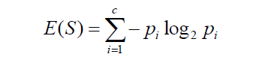  
  Information Gain (IG)  
   It tells which attribute or feature is most important.  
    
  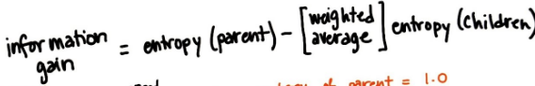  
  Here, the entropy(children) is the sum of entropies of all the possible values in a feature with respect to all the available output label values.  
  Example,  
  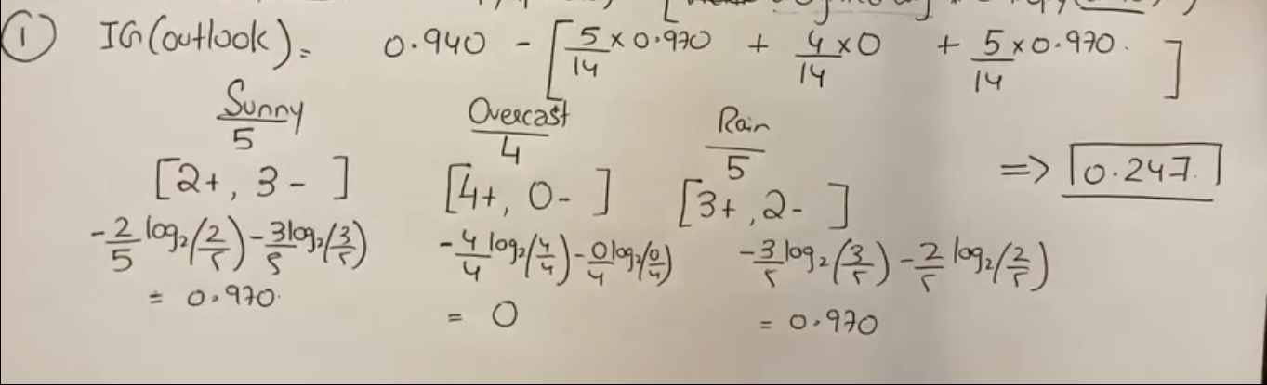  
    
  Here, + represents 🡪 when output was YES, - represents 🡪 when output was NO  
   when calculating IG for feature “Outlook” we saw there are total 3 possible values for outlook feature (Sunny, Overcast, and Rain) then we checked how much “Sunny” out of total are part of output label “YES” from the total 🡪 2/5 and calculated its entropy, and then we saw how much “Sunny” out of total are part of output label “NO” that is 🡪 3/5 so we calculated their entropies and summed them, this resultant entropy is called **entropy(children)**. Same is done with other possible values of outlook feature and finally we multiplied all the children’s entropies with the “**Weighted sum**”.   
  The **weighted sum** is 🡪 (Favorable values consider all the output labels) / (**Total values in Parent’s nodes**).  
    
  **We do not divide with Total value in feature node but we divide with total feature values of parent’s node. For now, there was no parent node in the tree that is why we considered the output feature as parent and since output feature has 14 total values that is why we divided it by 14 otherwise if there exist any parent node in tree then we would have only divided by total entries or total values of that parent node only for weighted average calculation if we don’t do this then we any not get any dead end.  
    
  Also, when counting total favorable values for both IG and entropies calculations, we will only see those rows that contains parent node value. This difference can be seen once we have a root node having its values as children and we will be calculating IGs and entropies for other features.**  
    
    
  Example,

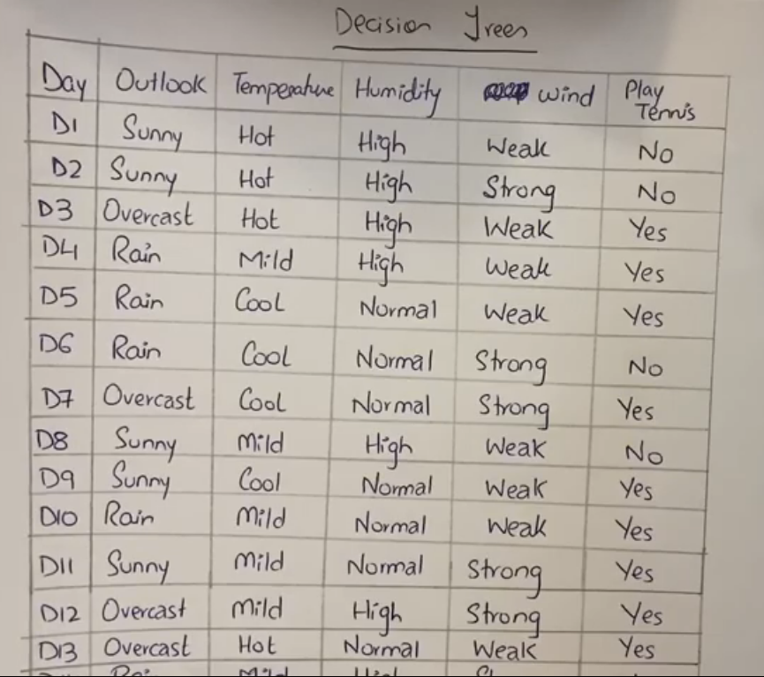  
  
Step # 1 (Find root attribute node of the tree)  
 See the output attribute and calculate its entropy because we need entropy of parent node in information gain formula but since there is no node in tree currently so we will treat entropy of output variable or feature as the “entropy of parent”.  
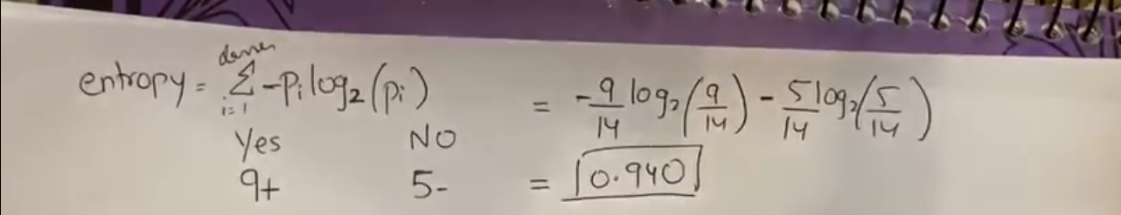  
  
Now calculate information gain values for each feature and the feature with largest IG value will become our root node of the tree because IG value tells us which feature is more important for prediction. So, the feature with maximum IG value should become the root node.  
  
  
  
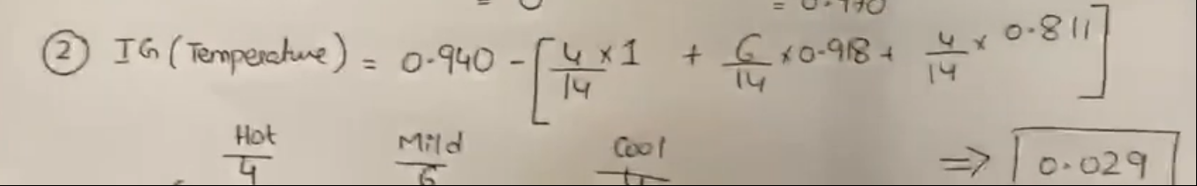  
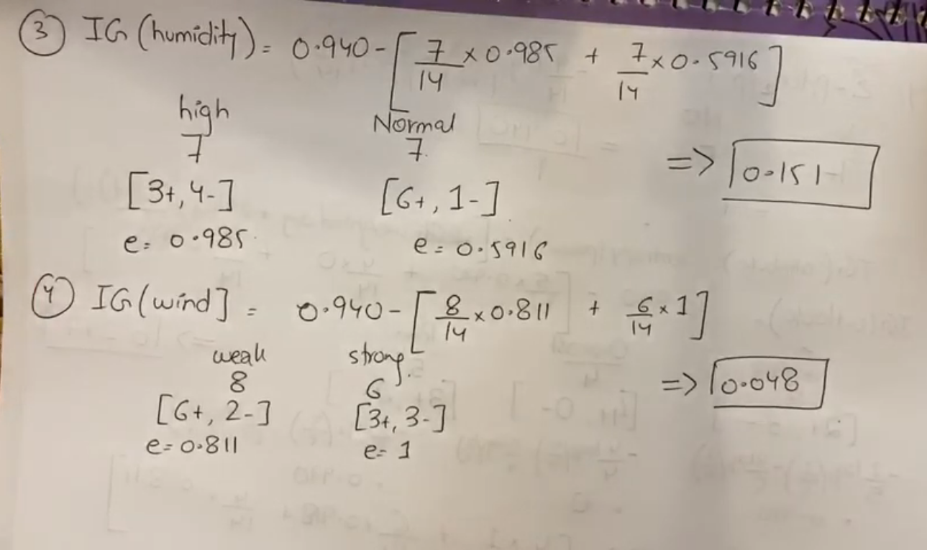  
Therefore, **outlook** feature will become the root node of the tree because it has maximum IG value and all the possible **“VALUES”** of outlook feature will become its children.  
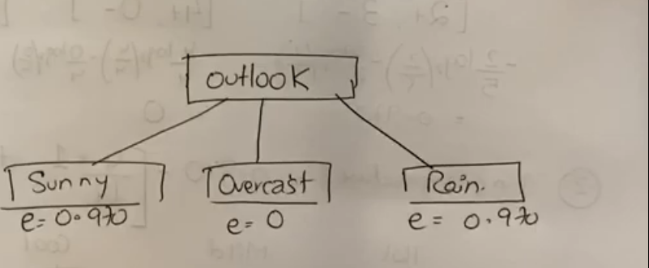  
  
Here,  
e 🡪 0.970 is the individual entropy of value “**Sunny**”.  
e 🡪 0 is the individual entropy of value “**Overcast**”.  
e 🡪 0.970 is the individual entropy of value “**Rain**”.  
  
Note: Entropy comes “0” when all the values belong to one output variable only. Here Overcast has entropy 🡪 0 because whenever overcast came, the output label was “YES” (All the values are part of specific output label). Whenever any value has entropy 🡪 0 then there is a **dead end** so we directly write the output once the dead end comes and continue the process for other values who does not have dead end yet. We will stop when there will be a dead end for all the values.  
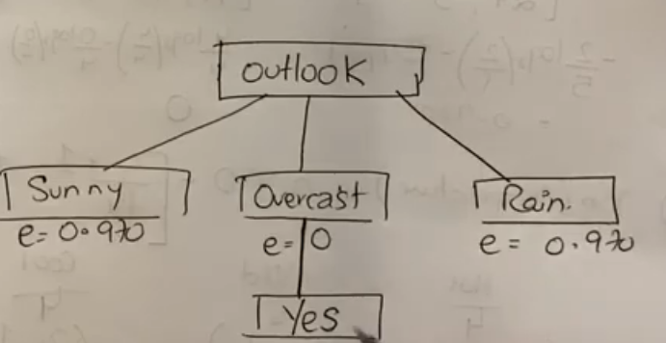  
  
Now, our next parent node is “**Sunny**” if we make tree from left to right which is from one of the possible values of feature “**outlook**”. Now we will only **see the rows that has “Sunny”**. Now the remaining features are Temperature, Humidity and Wind. **We will not consider Parent features that were assigned to above LEVELS of tree** anymore, we will consider only the non-parent features that are remaining at current level. Therefore, for **Sunny, Overcast,** and **Rain**, we will calculate IG, and entropy values for 3 features only (Wind, Humidity and Temperature). We will treat node “**Sunny**”, “**Overcast**” and “**Rain**” as the parent of these remaining features while calculating the IG, entropy values.  
  
Now, we will divide by “**5**” instead of 14 because **total parent node value rows are 5 (rows that contains sunny)**  so when calculating weighted averages, we will divide by **5** and we will search favorable values in numerator **only in the rows that contains parent node values (sunny).**Therefore, we will now calculate IG and entropy values as,  
  
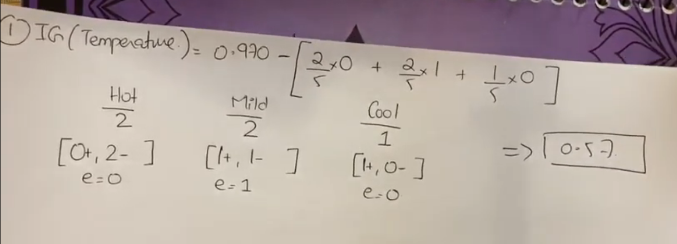  
  
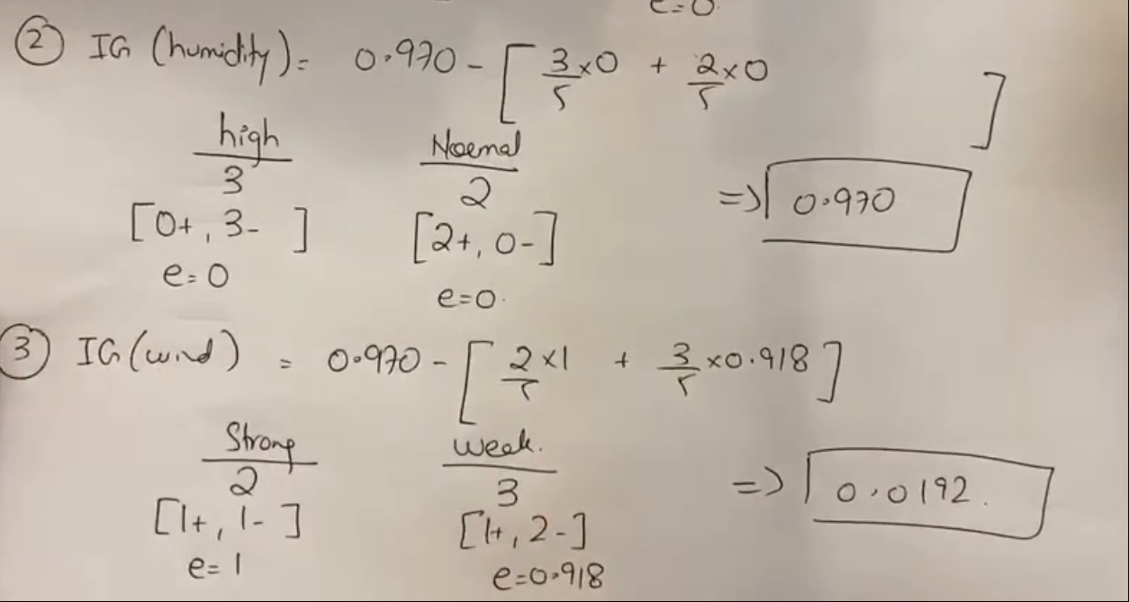  
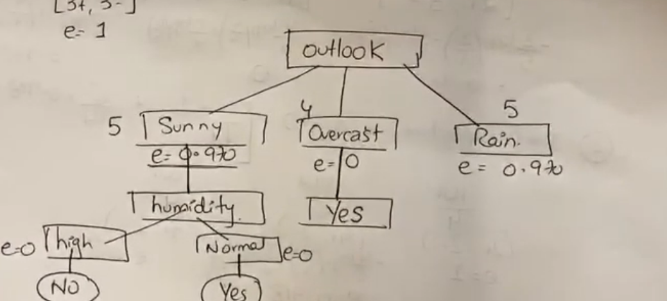  
  
Entropy value 🡪 1 (when output label is equally divided)  
Entropy value 🡪 0 (when only single output label contained by all the rows **having parent node value**.)  
**If entropy 🡪 0 then there is a DEADEND**  
  
Now, our new and remaining parent node is “RAIN” because Overcast already has a **dead-end** and **non-parent remaining features** are still “Temperature”, “humidity” and “Wind” so we will now calculate IG and entropy values while **considering the rows having “RAIN” as value**  
  
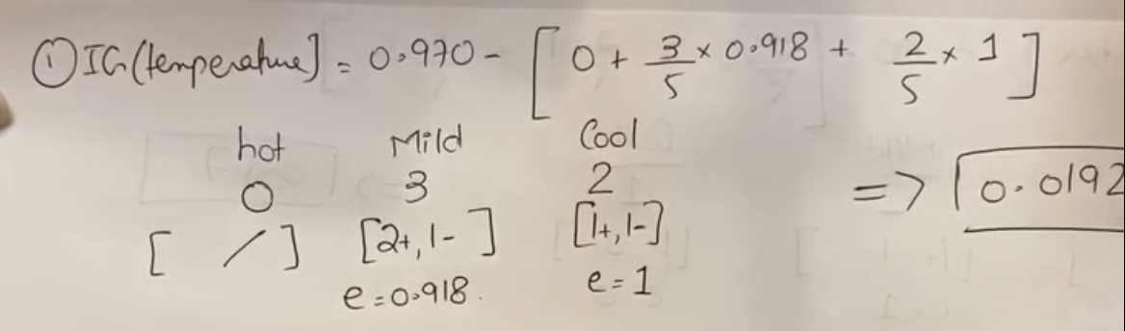  
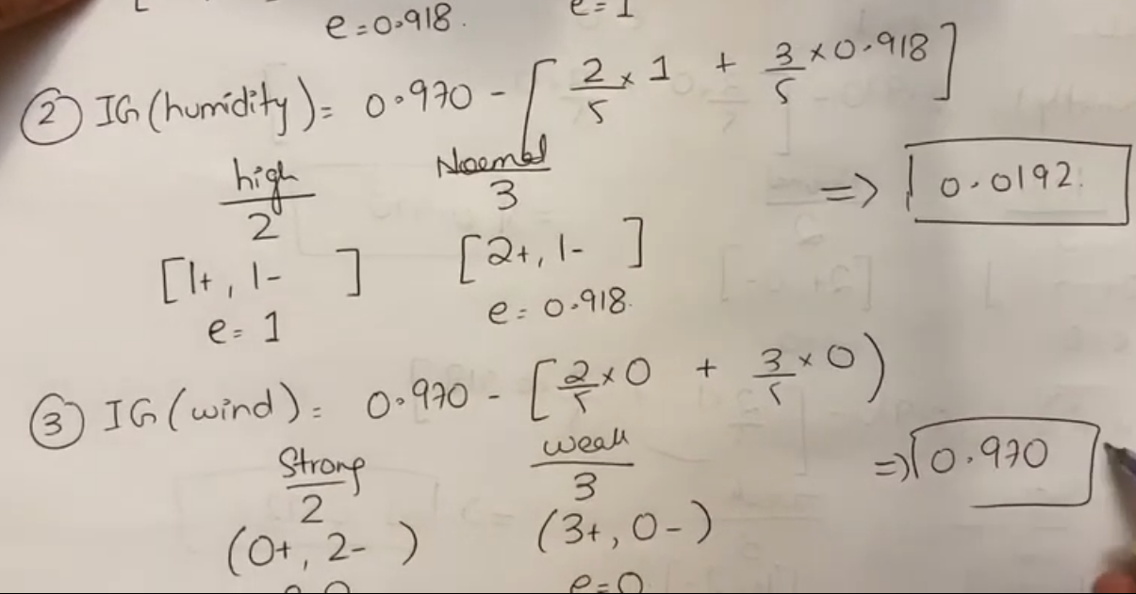  
  
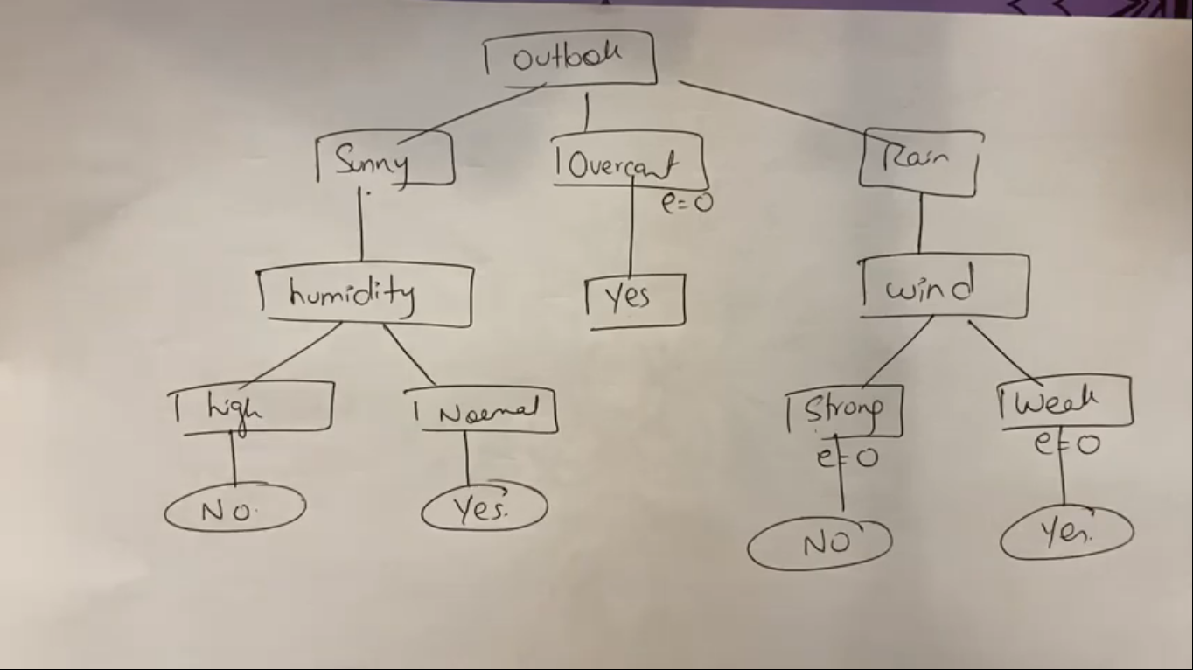  
  
  
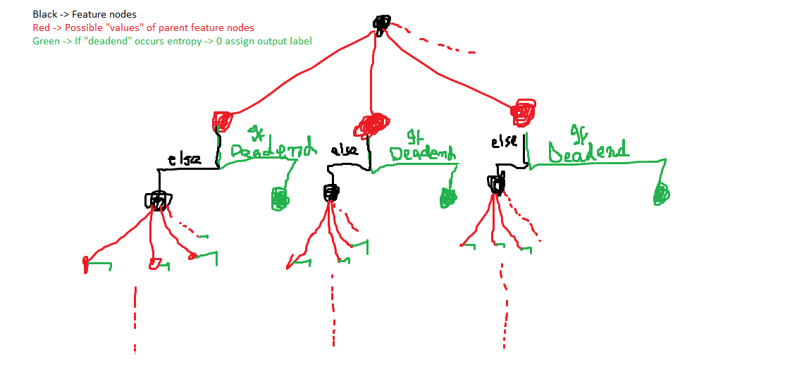

Alpha Beta Pruning  
  
  
Algorithm  
  
1. Start Traversing from Left to Right in depth first search manner.  
  
2. Check values at depth and pick max/min wrt to the current level of the tree.  
  
3. Once value is select either wrt min’s turn or max turn, we also add condition with that value if the current node is at min level, then < (value) “lesser than condition” will be assigned to that node and if the current node is at max level, then >= (value) “greater than condition” will be assigned to that node.  
  
4. Now check remaining leaf values and compare with previous assigned value + condition of current node if new value is satisfying the current node condition, then **update** value but **don’t update condition** operator because it depends on min or max level whatever the level is, that condition operator is assigned.  
  
Note :While checking condition with current node, if we get a value that cannot be passed to parent node like in the example, in middle path when we got “2” we know that we can only update 2 when we get value lesser than 2 so even we cannot pass “2” to the predecessor node or parent node of current because its condition is >3 so “2” even if get updated and becomes lower by checking remaining values then even it is useless to even see those value and update in place of “2” so we **DO NOT CHECK** remaining value when there is a conflict in current node’s condition and its parent node condition.  
  
5. Pass the value to the parent if current node value is satisfying the parents condition and then check remaining branches of parent node.  
  
6. If parent and child have any **conflict** in their conditions, prune the rest of the branches.  
  
Example # 1,  
  
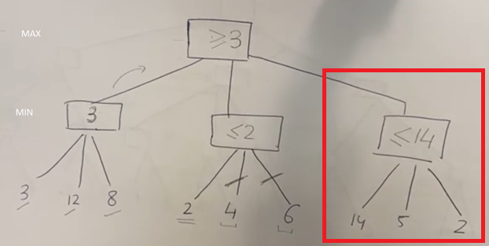  
  
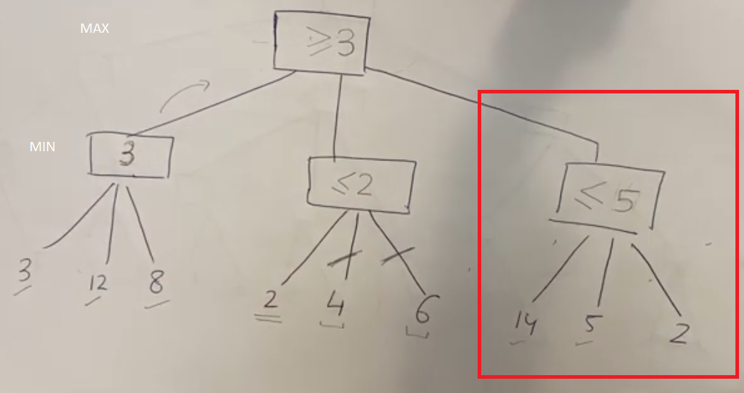  
  
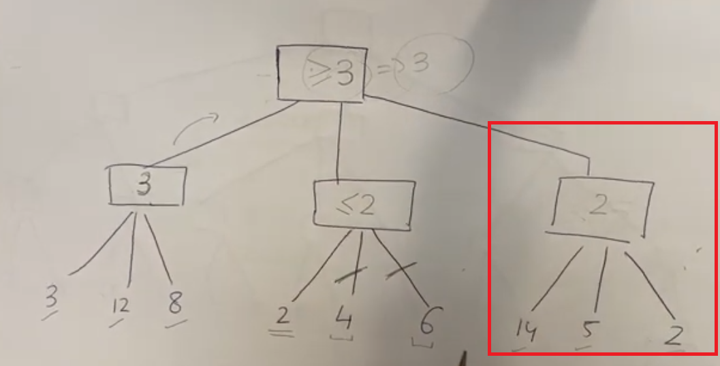  
  
  
  
  
  
  
  
  
  
  
  
Example # 2,  
  
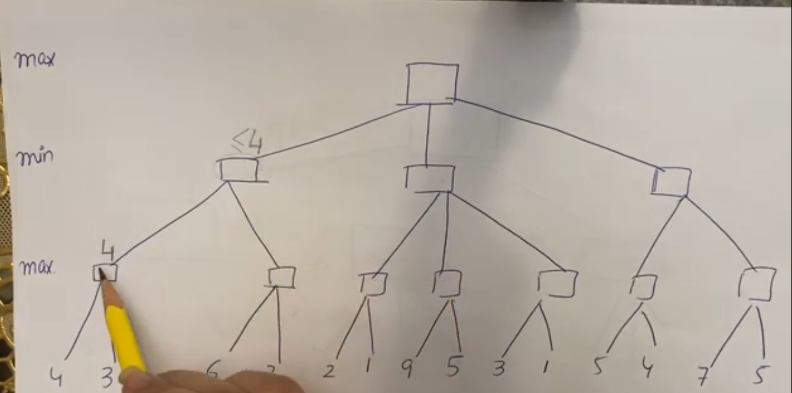  
  
  
Now, the conflict comes in the conditions of parent(predecessor) node and the current node. Since after checking or reading “6” we updated current node’s condition to >=6(max level) so now current node can only have values >= 6 however the parent node needs value <= 4 to get updated. So, current node can never have values <=4 because it first read value 6 and made its condition >6 so even if we check remaining values so it is useless to check them because current node can only have values >=6 that we cannot pass to parents node because it need <=4.  
  
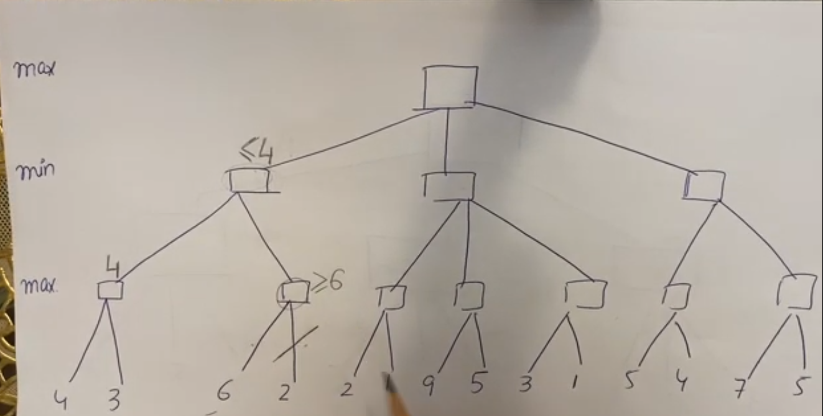  
  
  
  
  
**Do not forward updated values to child nodes.**  
We pruned Node (9,5), and (3,1) because there was a **conflict** between parent and child conditions so whenever a conflict arises do prune the remaining branches.  
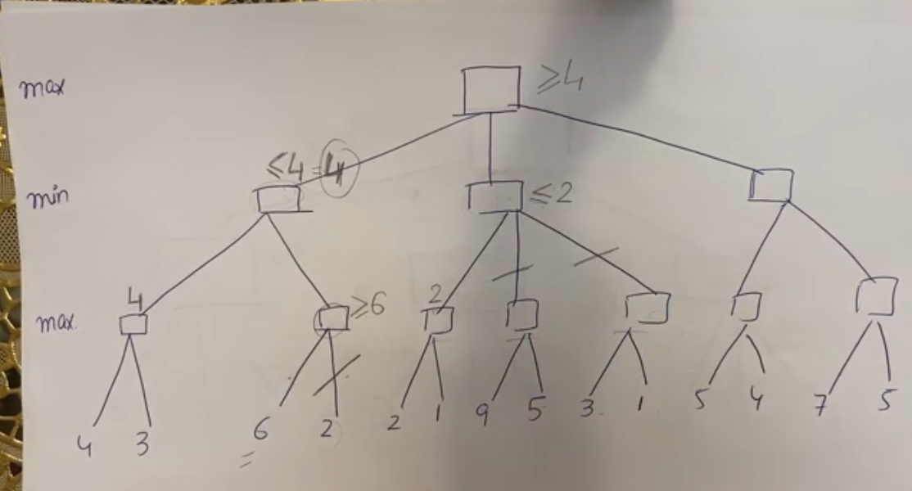  
  
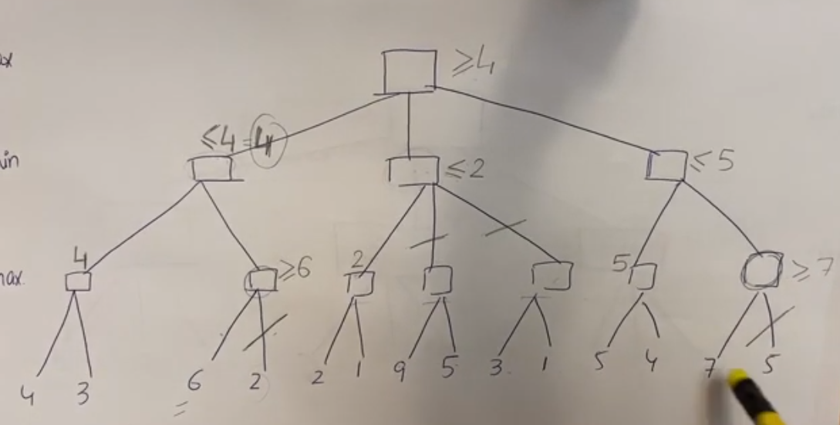  
  
  
  
  
  
  
  
  
 Constraint satisfaction problem(CSP)  
  
**Variables** 🡪 jinko koi value assign kerni ho. Also, variables are always different like queen1, queen2 …. Etc. example 🡪 queens ko column mein se koi place assign kereinge but column ki koi value assign nahi hoskti queen ko that is why variable here is queen.   
**Domains** 🡪 jo values assign ki jayen example 🡪 column places will be assigned queens. Also, domain values are always same like red, green, and yellow, only this specific or fix set of values can be assigned therefore same domain can be assigned to multiple variables but variables are always different.  
**Constraints** 🡪 jin restrictions k sath assignment hogi. Also, constraints are always between the variables. e.g no queens at diagonal, column or row of another queen, no neighbors can have same colors etc.  
Constraints in language can be defined as,  
 **Previous state before constraint + Time(add time only if there is a time limit else use any variable ‘t’) <= next state after constraint.**  
  
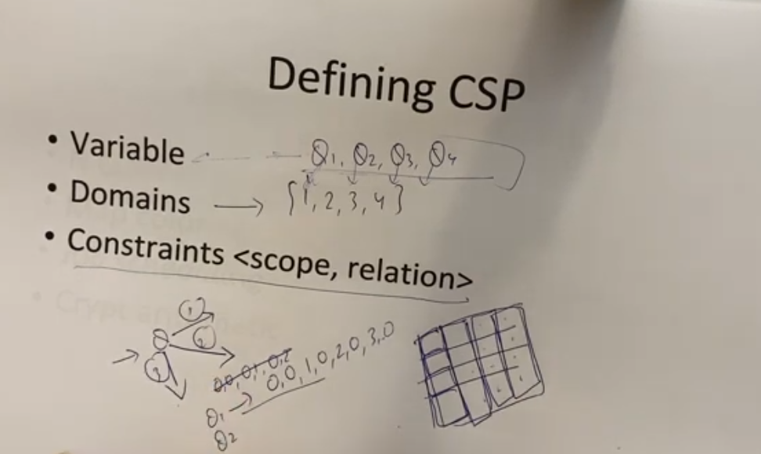  
  
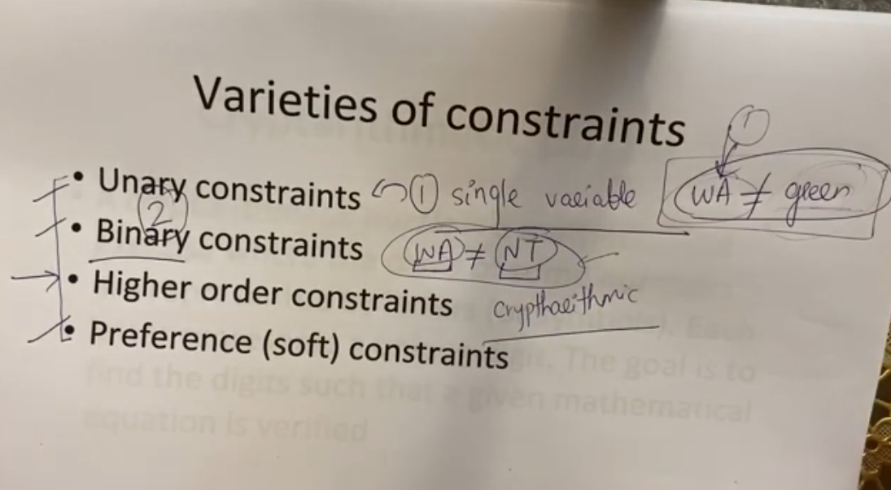  
  
When there is a constraint that is only for specific node like WA should not have color green, this is called **unary constraints**.  
  
When there are two variables included for a constraint, then it is called **binary constraint**. For example, WA should not have color similar to NT. Here WA and NT are variables and colors are domain values.  
  
Super set of unary, binary constraint with an additional constraint variable >=3. It means 1,2,3…. n variables can be included in higher order constraints.  
  
  
  
  
  
  
  
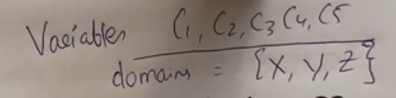  
  
Classes 🡪 variables because professors are assigned to it  
Domain 🡪 Professors  
Constraints 🡪 Timing of classes, a professor cannot teach two classes at a time.  
  
  
Write possible domains for each variable in a set notation from given instructions.  
First point tells to include X professor in C3 and C4 variable’s sets.  
Second point tells Y should be included in the set of C2,C3,C4,C5 variable classes.  
and so on..  
  
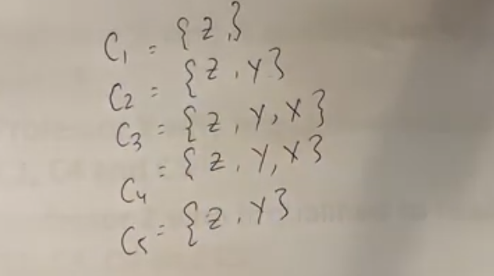  
  
  
  
See overlapping and generate constraints between the variables. Except for the unary constraints, all other constraints are between the variables. Only the unary constraint has variable to domain constraint.  
  
Here C1 != C2 because C1’s time is overlapping with C2. See up to down but do not see down to up again once constraints are made because it will generate the same constraints again.  
Similarly C2 != C3 because their timings are overlapping  
and so on..  
  
  
  
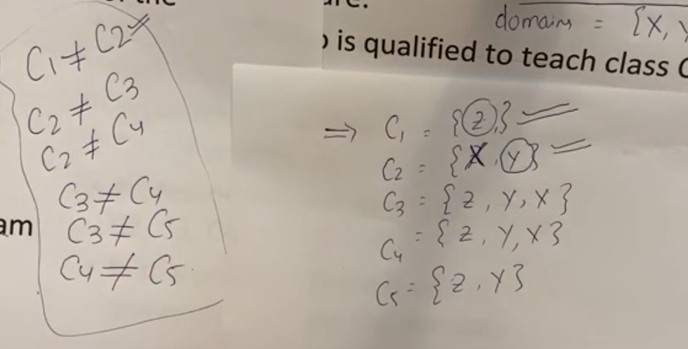  
  
Once the constraints and possible domain set is generated, we will make the solution for this problem.  
For class 1 there is only 1 professor and constraint # 1 tells that C1 != C2 so we removed Z professor from C2 because it was already assigned to C1. Similarly, when making solution for C2, we selected Y professor because it was the only remaining or available professor in the set of C2 and constraint C2 tells that professor of C2 should cannot teach class C3 so we removed Y from C3 and so on...  
  
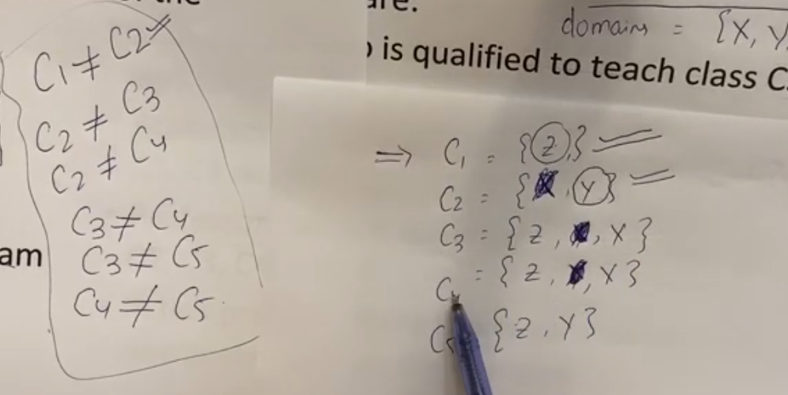  
  
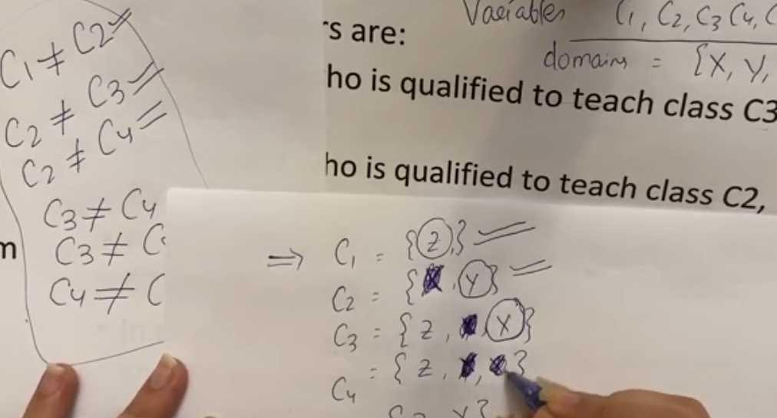  
  
For C3, there are two choice we can choose any professor we want but we chose X and removed X from C4,C5 due to the constraint of class C3 != C4 and C3 != C5.  
  
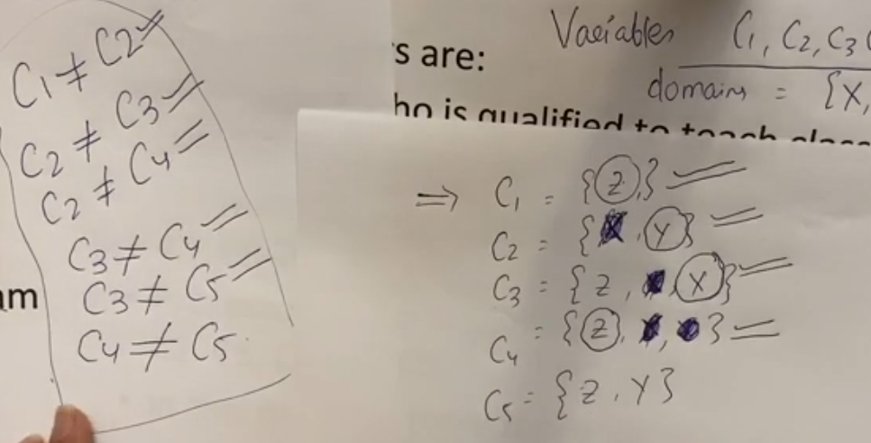  
  
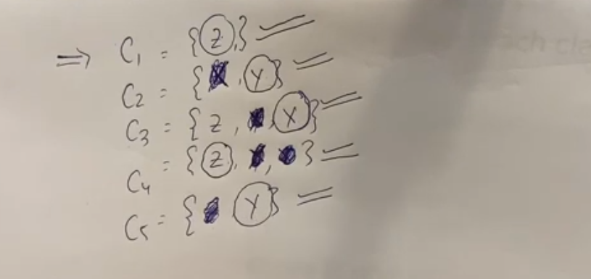  
  
By Shrinking (Removing) other variable’s domain, we are able to find solutions easily. This is how the CSP work.  
  
  
  
 Caesar Cypher  
  
Equations made in Caesar Cypher are its constraints.  
  
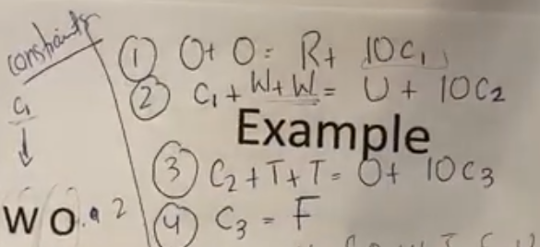  
  
  
  
  
  
  
  
  
  
  
Decrypted Data  
  
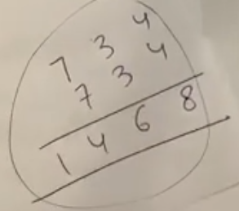  
  
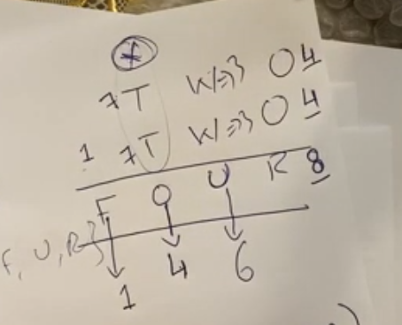  
  
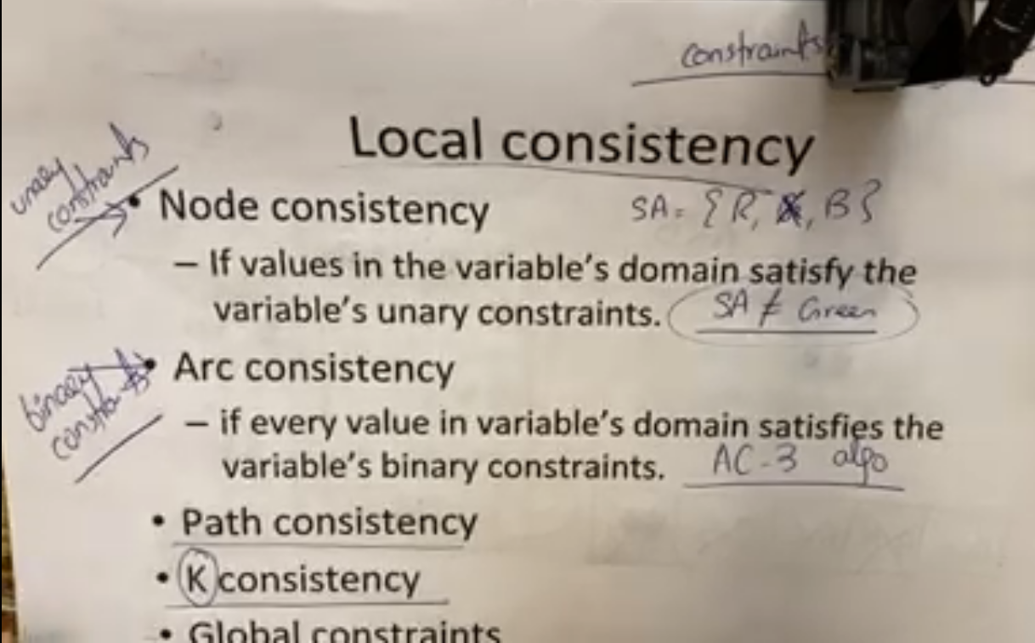  
  
Making the variables to follow all the constraints is called Consistency.  
Node Consistency 🡪 A single node (Variable) following all its constraints.  
  
Arc Consistency 🡪 Two variables following their constraints together is called Arc Consistency. When we try to follow the constraints of one variable, another neighbor variable’s domain gets affected.  
  
Path Consistency 🡪 Three variables get introduced and follow their constraints together is called path consistency.  
  
K-Consistency 🡪 N number of variables following their constraints together is called K-consistency.  
  
  
  
  
  
  
  
  
  
  
  
  
  
  
  
  
  
  
 Example of Arc-Consistency  
  
Initial domain {1,2,3,4} for each node and constraints (A<B , B,C),  
  
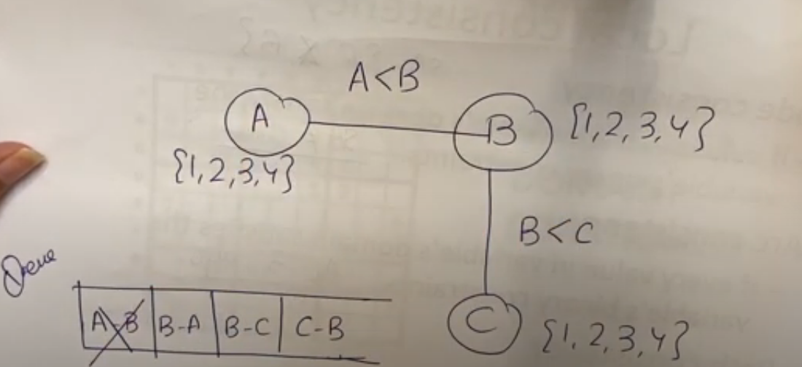  
  
Since the edge(arc) is not directional so we will consider both the directions A 🡪 B, B 🡪 A, B 🡪 C, C🡪 B  
and push them in a Queue. Now we will pop out the first arc and update its domain with its constraint.  
A’s initial domain 🡪 {1,2,3,4} but since A should be lesser than B therefore for each value in A there should exist some numbers in B from which A is lesser...   
For 1 there exist 2,3,4 from which 1 is lesser  
For 2 there exist 3,4 from which 2  
For 3 there exist 4 from which 4  
For 4 there is no number in B’s domain that is greater than A’s currently selected domain therefore we will remove 4 from A’s domain.  
  
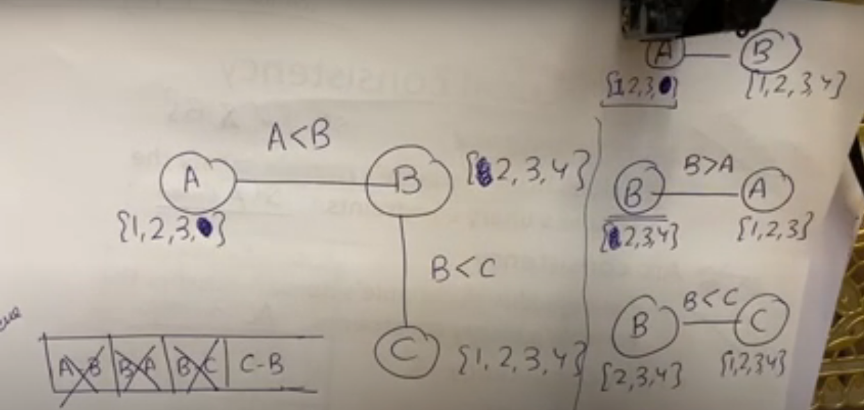  
  
Similarly, when for calculating B🡪A, we saw that, for 2,3,4 there exist some values in A from which B is greater but for “1” there exist no value in A from which B(1) is greater.  
Now, when we calculated B🡪C, the consistency of B get updated so we will push all the child🡪B path in the queue again because due to the impact on B’s domain from other neighbors of B, the remaining neighbor’s of B can have some updates in their consistency. Therefore, pushing A🡪B in the queue and we will only check A🡪B not B 🡪 C because only child🡪Parent is pushed in the queue and parent here is “B”.  
Once the queue becomes empty, all the variables become consistent.   
  
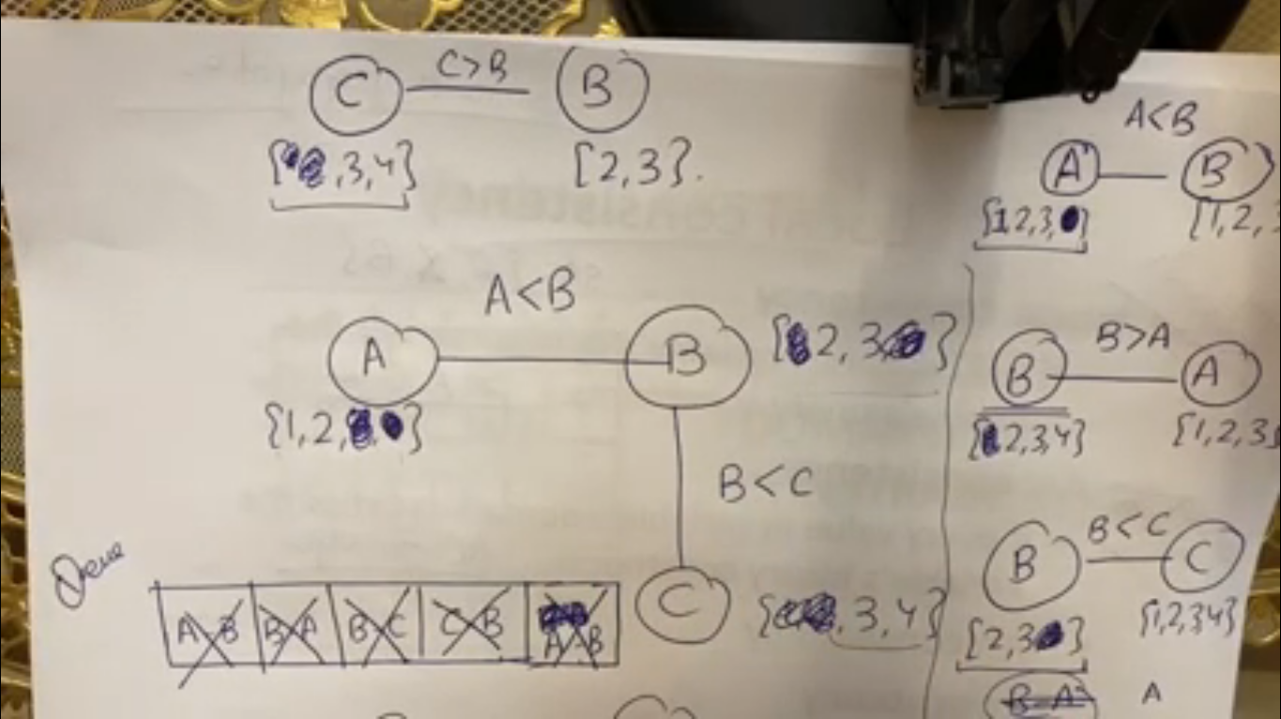  
Making the variables arc-consistent does not mean that we can have solution.  
  
**Path Consistency**  
Here, in this problem we have two colors only and we have to assign them in such a way that we get a solution. We want to assign WA-NT && NT-SA which means when assigning a color to either WA, and SA we should also see the constraint of the variable commonly connected in between them so there are 3 variables now. So doing arc-consistency twice can give us this. So, by making WA-NT arc consistent and NT-SA arc consistent, still we do not have a solution and that is why apply arc consistency twice to some variables having some common variables in them is called path consistency. These nodes are consistent but there exists no solution. Therefore, consistency does not guarantee or lead to solutions.  
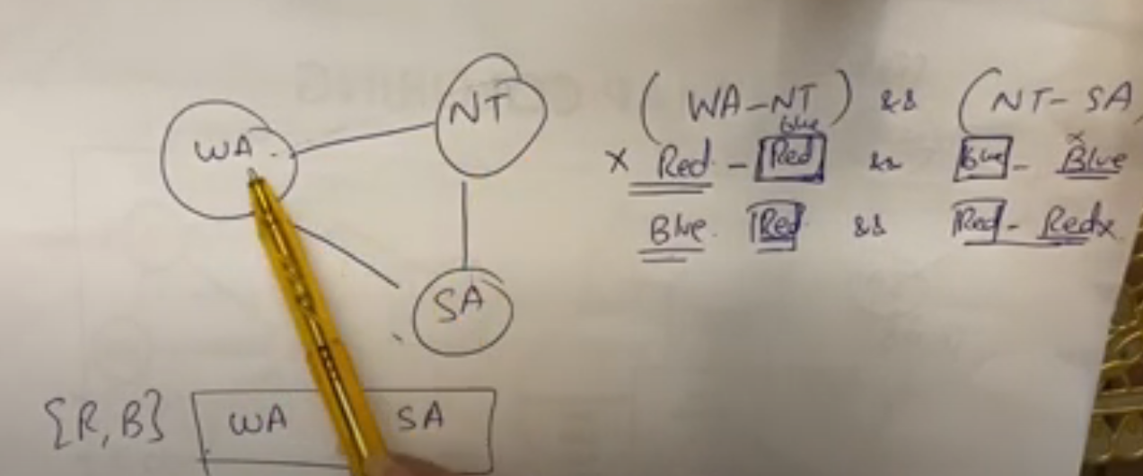  
  
  
  
  
  
  
**Global Consistency**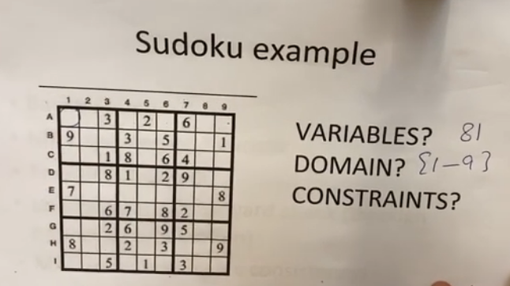The assignment of a number to a box should not have any already assigned number from its row and column and also not from its own 3x3 box. This is an example of global consistency when we have variable constraints out of the box. **Bound Propagation  
  
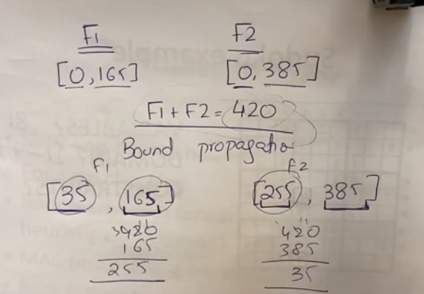  
  
We have two flights F1,F2 that combine should have passengers 420 and their min, max capacities are given. Find bound propagation.  
  
For F1 🡪 [ Total – F2 Max, Initial max of F1]   
For F2 🡪 [ Total – F1 Max, Initial max of F2]**  
  
  
  
  
  
  
  
  
  
  
  
  
  
  
  
  
  
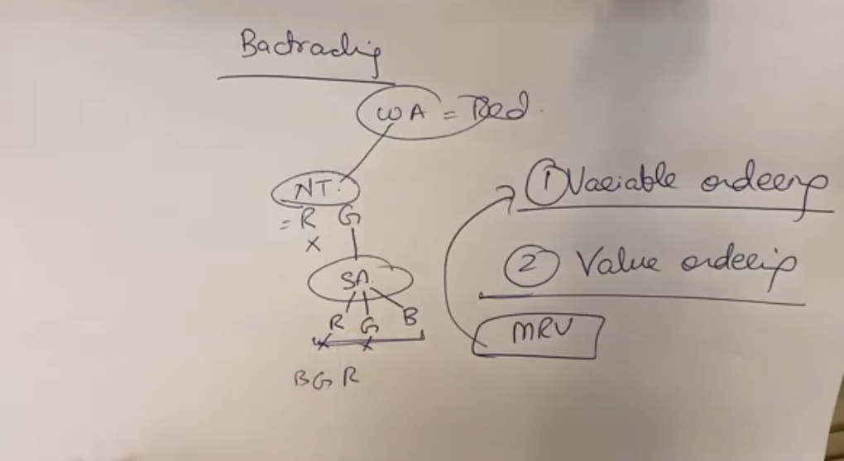  
  
Normal backtracking randomly selects and compare for each color. Let suppose if we assign WA = Red, NT = Blue and Q = Green so when we will be assign SA a color there will be no color remaining for SA because its domain has shrink totally and there is no color left to assign SA because normal backtracking was assigning colors are random and was backtracking if there is no possibility left by comparing with the neighbors so in this case also, when assigning to SA we will backtrack and assign different colors to the neighbors to assign proper color to SA in such a way SA has some color in its domain. This normal backtracking process takes too much time because of random selection and comparison of node so we wanted to improve this so there are two approaches to improve this problem.   
  
1. Variable ordering 🡪 We should always select variables that has minimal domain so that they get their colors first instead of picking nodes at random at any order. By this approach of checking minimal remaining domain, there will be no such problem for SA. MRV is an example of variable ordering.  
  
2. Value Ordering 🡪 We should pick those nodes and assign colors to those nodes first that shrinks minimal domain of other node because a node can shrink many domain values of other nodes if selected and compared at random. MCV is an example of value ordering.  
  
  
  
  
  
  
  
  
  
  
  
  
  
  
  
  
**MRV**  
  
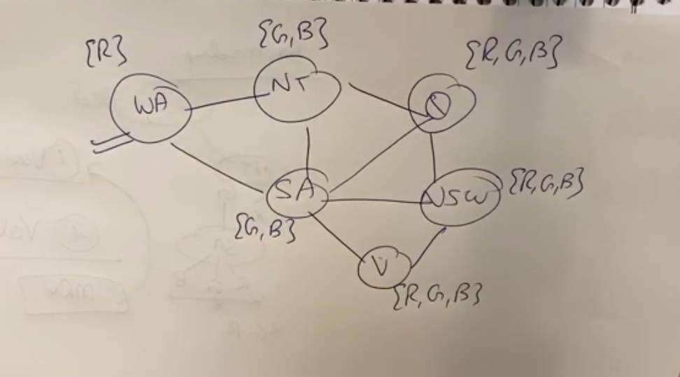  
  
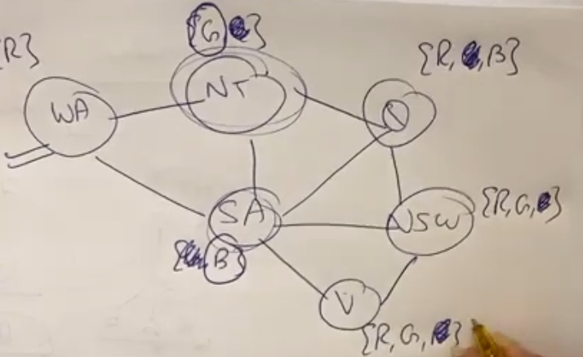  
  
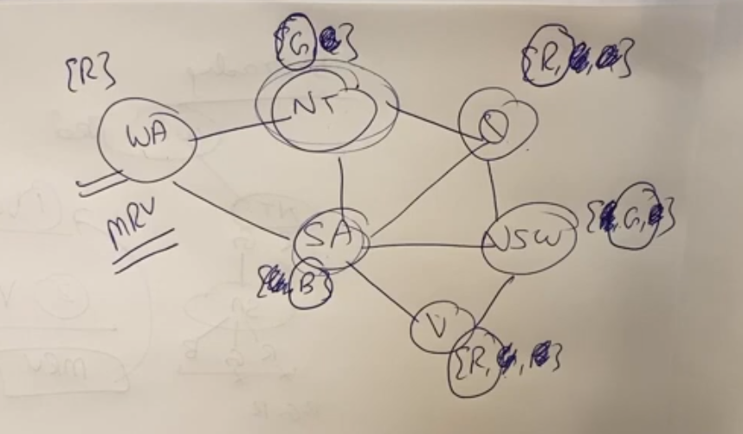  
  
  
  
**MCV**  
  
  
  
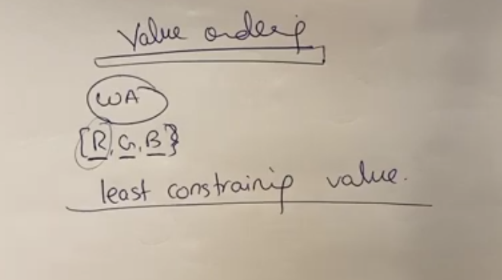  
  
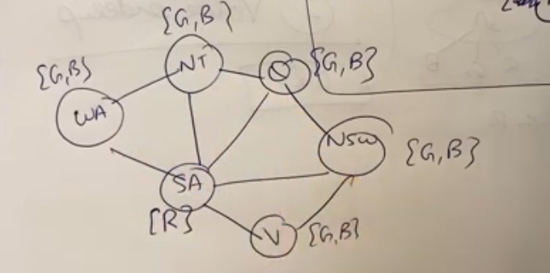  
  
Select node that has higher degrees (highest number of neighbors) and assign them colors.  
